

**PROJECT RECORD**

**2022-2023**

**PERFICIENT**



| Roll No._______________ |
| --- |
| Name: _________________________ |
| Class:____________ Sec:___________ |
| Subject:________________________ |





***Certificate***

**Roll No. _________________**

This is to certify that Miss/Master_________________________ of grade __________________ section _____________ has carried out project work in Assignment prescribed by the Central Board of Secondary Education, New Delhi during the academic year 2021-2022.

Teacher-in charge: Ms. Shenooja Pareed

Date: _________________

___________________ ____________________

External Examiner Internal Examiner

***Contents***

* Acknowledgment
* Introduction
* Synopsis
* System Description
* Program Coding
* Output
* Conclusion
* Bibliography

***Acknowledgment***

While bringing out this thesis to its final form, I came across a number of people whose contributions in various ways helped my field of research and they deserve special thanks. It is a pleasure to convey my gratitude to all of them.

First and foremost, I would like to express my deep sense of gratitude and indebtedness to my teacher Mrs. Shanooja Pareed for his invaluable encouragement, suggestions, and support from the early stage of this project and for providing me with extraordinary experiences throughout the work. Above all, his priceless and meticulous supervision at each and every phase of work inspired me in innumerable ways.

I especially acknowledge her for her advice, supervision, and vital contribution as and when required during this research. His involvement with originality has triggered and nourished my intellectual maturity which will help me for a long time to come. I am proud to record that I had the opportunity to work with an exceptionally experienced teacher like her.

I am highly grateful to Mr. K George Mathew, Principal, Gems United Indian School, and Mr. K Joseph, Supervisor (grade 8-12 boys), for their kind support and permission to use the facilities available in the school.

Finally, I am deeply indebted to my mother, Mrs. Subha K.P, my father, Mr. Biju K.V, my uncle, Mr. Rathin, and my family members for their moral support and continuous encouragement while carrying out this project. I dedicate this project to the budding new generation of future entrepreneurs

***Introduction***

Business is a very demanding profession that has broadened and been popularized over the years. A business requires high skills of management, teamwork, patience, mental strength, and effectiveness of work. A person should be mentally prepared to accept the fall of a business at any point time in their life since it is not always secure. But, if planned properly, with help from experts, and patiently blossomed over the years, then a business has a greater rate of success.

Business generally works with the coordination of several activities. Accounting, financial management, manufacturing, marketing, research and development, safety, and sales management are the various components that need to be tended to while running a good business with the aim of success. Investors, creditors, and regulators play a pivotal role in the profit of a business.

Keeping the above factors in mind, I present to you a back-end prototype that may well prove to be the pioneer leading us into the next era of big data management! A glimpse of the future coupled with an interesting example proves to be the perfect recipe for a masterpiece while serving a cryptic warning to the summit of modern nations.

*Synopsis*

Managing business data has evolved over time into something termed “BIG DATA MANAGEMENT”, it is the art of collecting and storing data that may prove valuable to a certain company. Managing a large amount of data may prove to be a hassle at times, so why not centralize the data in a single company database? The said project aims to do the same, though in its premature stage of only having a back-end system it may well prove a game changer at its best.

Space, codes, and business. Three of the most fascinating topics, intertwined to present a logical, affirmative, and innovative idea. As the saying goes “a good example has twice the value of a good example”, we start with a company aptly named “PERFICIENT” which aims to realize our age-old dreams of space exploration and a new concept of “interplanetary warfare”.

The main objective of this prototype is to provide a sneak peek into the working of a company and its different levels ranging from a super admin to an employee or even a business partner! The project presents business intelligence in a nutshell through simple but effective coding techniques.

The backend system presented, allows a super admin to access all aspects of a company (in this case perficient), an employee the access to limited areas assigned to each of them by the super admin alone, Last but definitely not the least, the young aspirants and partners. The partners are allowed to place orders, edit existing ones or cancel orders with the firm. The aspirants on the other hand are allowed to view the company's perks and achievements making it easier for them to make a concrete decision on whether or not to join our family and submit applications for the career postings put up by the HR departments. The system is based on unique IDS for each of the functionalities which forges a rather well-oriented security system when combined with the usual passwords.

Though this project allows all the functionalities through the simple function definitions and if-elif-else ladders, it could be developed further through various different ideas like Tkinter which would provide easier access to everyone involved. As a firm believer in “there’s always room for improvement”, I believe it may not be perfect, but it reflects a fraction of my abilities.

*System Description*

FILE NAME: PERFICIENT

IMPORT STATEMENTS: import mysql.connector as m

from time import sleep

import random

from pygame import mixer

BUILT IN FUNCTIONS: cursor()

fetchall()

upper()

excecute()

commit()

mixer.init()

mixer.music.load()

mixer.music.play()

USER DEFINED FUNCTIONS: ADD_TO_CATALOGE()

ADD_TO_RESEARCH()

ADD_TO_CLIENT()

ADD_TO_SALES()

ADD_TO_EMPLOYEE()

ADD_TO_CAREERS()

ADD_TO_APPLICATIONS()

DELETE_PROJECT()

DELETE_EMPLOYEE()

DELETE_CATALOGE()

DELETE_CLIENTS()

CANCEL_ORDERS()

DELETE_OPENING()

UPDATE_EMPLOYEE_DETAILS()

UPDATE_PRODUCT_INFO()

UPDATE_PROJECT_INFO()

UPDATE_CLIENT_DETAILS()

UPDATE_SALES()

UPDATE_CAREERS()

LOGO()

BOOT_UP()

ADMIN()

USER()

EMPLOYEE()

SELECTED_ACCESS()

BUSINESS_USER()

PERSONAL_USER()

DELETE_USER()

SALES_MANAGER()

PROJECT_DESIGNER()

PRODUCT_MANAGER()

HR()

VARIABLES:

PRODUCT_ID: GENERATES A UNIQUE AND RANDOM ID FOR PRODUCTS

PROJECT_ID: GENERATES A UNIQUE AND RANDOM ID FOR PROJECTS

CLIENT_ID: GENERATES A UNIQUE AND RANDOM ID FOR CLIENTS

TRANSACTION_ID: GENERATES A UNIQUE AND RANDOM ID FOR TRANSACTIONS

EMPLOYEE_ID: GENERATES A UNIQUE AND RANDOM ID FOR EMPLOYEE

PRODUCT_NAME: ASKS ADMIN TO INPUT THE NAME OF PRODUCT

PRICE: ASKS ADMIN TO INPUT THE PRICE OF PRODUCT

PROJECT_NAME: ASKS ADMIN TO INPUT THE NAME OF THE PROJECT

COUNTRY_OF_ORIGIN: ASKS ADMIN TO INPUT THE COUNTRY OF MAKE

DATE_OF_INITIATION: ASKS ADMIN TO INPUT THE INITIATION DATE

EXPECTED_ARRIVAL: ASKS ADMIN TO INPUT THE EXPECTED ARRIVAL

COST_OF_PRODUCTION: ASKS ADMIN TO INPUT THE COST OF PRODUCTION

COST_OF_TRANSPORT: ASKS ADMIN TO INPUT THE COST OF TRANSPORT

TOTAL_COST: CALCULATES THE SUM OF THE TWO COSTS ENTERED

CLIENT_NAME: ASKS ADMIN TO INPUT THE NAME OF THE CLIENT

CLIENT_CONTACT: ASKS ADMIN TO INPUT THE CONTACT DETAILS OF CLIENT

QUANTITY: ASKS THE CUSTOMER TO INPUT THE QUANTITY OF PRODUCT

COST_PER_UNIT: ASKS THE CUSTOMER TO INPUT THE COST PER UNIT

COMPANY_NAME: ASKS THE CUSTOMER TO INPUT THE COMPANY NAME

TOTAL_PAYMENT: CALCULATES THE TOTAL AMOUNT TO BE PAID

EMPLOYEE_NAME: ASKS ADMIN TO INPUT THE NAME OF EMPLOYEE

GENDER: ASKS ADMIN TO INPUT THE GENDER

DOB: ASKS ADMIN TO INPUT THE DOB OF EMPLOYEE

SALARY: ASKS ADMIN TO INPUT THE SALARY OFFERED

DATE_OF_JOIN: ASKS ADMIN TO INPUT THE DOJ

MEDICAL_ALLOWENCE: CALCULATES THE ALLOWANCE USING SET PARAMETERS

CONTACT_NO: ASKS ADMIN TO INPUT THE CONTACT DETAILS

ACCOMMODATION ALLOWANCE: CALCULATES THE ALLOWANCE USING SET PARAMETERS

DESIGNATION_APP: ASKS THE ADMIN TO INPUT THE DESIGNATION TO BE OPENED TO PUBLIC

REQUIRED_YEARS_OF_EXPERIANCE: ASKS THE ADMIN TO INPUT THE REQUIRED YEARS OF EXPERIENCE

***NOTE: THERE ARE MANY SIMILAR VARIABLES USED UNDER CREATE DELETE AND UPDATE AS WELL***

*Code:*

*import mysql.connector as m #IMPORTS THE MYSQL CONNECTOR TO CONNECT THE PROGRAM TO THE DATABASE*

*from getpass import getpass #IMPORTS GETPASS TO CONCEAL THE PASSWORD ENTERED FOR ADMIN LOGIN (WORKS ONLY ON TERMINAL)*

*con=m.connect(host='localhost',user='root',password="Kiran@175",database='PERFICIENT')*

*print("SUCCESSFULLY CONNECTED")*

*print(con)*

*A=con.cursor()*

*def ADMIN(): #PASSWORD AND MENUS FOR ADMIN*

*PASSWORD = getpass("ENTER THE ADMIN PASSWORD: ")*

*if PASSWORD=='TP2005-06':*

*BOOT_UP()*

*from time import sleep*

*delay=20*

*sleep(delay)*

*while True:*

*print("")*

*print("1. PROJECT PROGRESS")*

*print("2. PRODUCTS CATALOGE")*

*print("3. CLIENTS & DEALS")*

*print("4. RECRUITMENT")*

*print("5. WORK FORCE")*

*print("6. ORDERS")*

*print("7. USERS")*

*print("8. EXCLUSIVE ACCESS")*

*print("9. LOG OUT")*

*print("")*

*MC=int(input("WHAT WOULD LIKE TO DO FOR THE DAY? "))*

*if MC==1:*

*print('PROJECT PROGRESS')*

*print("")*

*print("1. NEW PROJECT FILE")*

*print("2. DELETE PROJECTS")*

*print("3. UPDDATE PROJECT SPECIFICS")*

*MC1=int(input("WHAT WOULD YOU LIKE TO TAKE A LOOK AT? "))*

*if MC1==1:*

*ADD_TO_RESEARCH()*

*elif MC1==2:*

*DELETE_PROJECT()*

*elif MC1==3:*

*UPDATE_PROJECT_INFO()*

*else:*

*print("SIR, YOU HAVEN'T CHOSEN A VALID COMMAND")*

*elif MC==2:*

*print("PRODUCT CATALOGE")*

*print("")*

*print("1. NEW PRODUCT LAUNCH")*

*print("2. TAKE DOWN UNDERPERFORMING PRODUCTS")*

*print("3. UPDATE EXSISTING PRODUCT SPECIFICS")*

*MC2=int(input("ANY CHANGES TO BE MAKE SIR? "))*

*if MC2==1:*

*print("PRODUCT LAUNCHES")*

*print("")*

*ADD_TO_CATALOGE()*

*elif MC2==2:*

*print("PRODUCT RETIREMENTS")*

*print("")*

*DELETE_CATALOGE()*

*elif MC2==3:*

*print("UPDATE PRODUCT SPECIFICS")*

*print("")*

*UPDATE_PRODUCT_INFO()*

*else:*

*print("TIRED SIR?, INVALID COMMAND ENTERED")*

*elif MC==3:*

*print("CLIENTS & DEALS")*

*print("")*

*print("1. UPDATE EXSISTING RELATIONS")*

*print("2. DISOLVE CLIENT CONTRACTS")*

*MC3=int(input("YOUR CHOICE SIR?"))*

*if MC3==1:*

*print("RENEWALS/UPDATE TERMS")*

*print("")*

*UPDATE_CLIENT_DETAILS()*

*elif MC3==2:*

*print("TERMINATE AGREEMENTS")*

*print("")*

*DELETE_CLIENTS()*

*else:*

*print("WRITE TO BE UNDERSTOOD,SPEAK TO BE HEARD,READ TO GROW...INVALID CHOICE SIR")*

*elif MC==4:*

*print("RECRUITMENT")*

*print("")*

*print("1. CAREER SIGNUPS")*

*print("2. RECRUITMENT PROCEDURE")*

*print("")*

*MC4=int(input("RECRUITING OR ISSUING A DEMAND GENIUSES ARE WE SIR?"))*

*if MC4==1:*

*print("CAREER SIGNUP POSTS")*

*print("")*

*print("1. PUT UP OPENINGS")*

*print("2. UPDATE REQUIREMENTS")*

*print("3. DELETE OLD/EXPIRED POSTS")*

*MCH1=int(input("ENTER YOUR CHOICE SIR: "))*

*if MCH1==1:*

*ADD_TO_CAREERS()*

*elif MCH1==2:*

*UPDATE_CAREERS()*

*elif MCH1==3:*

*DELETE_OPENING()*

*elif MC4==2:*

*print("RECRUITMENT PROCEDURES")*

*print("")*

*print("FOUND A GENIUS...HAVE YOU SIR?")*

*ADD_TO_EMPLOYEE()*

*elif MC==5:*

*print("WORK FORCE")*

*print("")*

*print("1. UPDATE EMPLOYEE DETAILS")*

*print("2. DELETE EMPLOYEE DETAILS")*

*MC5=int(input("WHAT DO YOU WANT TO DO SIR?"))*

*if MC5==1:*

*UPDATE_EMPLOYEE_DETAILS()*

*if MC5==2:*

*DELETE_EMPLOYEE()*

*elif MC==6:*

*print("ORDERS")*

*print("")*

*A.execute("SELECT * from SALES_TRANSACTIONS")*

*print(A.fetchall())*

*C1=input("BACK TO MAIN MENU? Y/N ")*

*if C1.upper()=='N':*

*exit()*

*else:*

*pass*

*elif MC==7:*

*print("USERS")*

*print("1. VIEW")*

*print("2. DELETE SPAM/BOTS")*

*MC7=int(input("SIR, WHAT DO YOU WANT TO CHECK OUR USERS?"))*

*if MC7==1:*

*A.execute("SELECT * FROM PERSONAL_USER")*

*print(A.fetchall())*

*if MC7==2:*

*A.execute("SELECT * FROM PERSONAL_USER")*

*print(A.fetchall())*

*print("")*

*DELETE_USER()*

*elif MC==8:*

*SELECTED_ACCESS()*

*elif MC==9:*

*print("SUCCESSFULLY LOGGED OUT!")*

*break*

*else:*

*print("INVALID COMMAND")*

*from time import sleep*

*if PASSWORD!="TP2005-06":*

*print("HIGH SECURITY SEQUENCE INITIANTED...")*

*delay=2*

*sleep(delay)*

*print("YOU ARE NOW LOCKED OUT OF THE ACCOUNT PLEASE CONTANCT THE IT DEPARTMENT @ PERFICIENT")*

*exit()*

*def EMPLOYEE(): #EMPLOYEE MENUS*

*u=input("ENTER YOUR USERNAME: ")*

*p=getpass("ENTER YOUR PASSWORD: ")*

*SQL321="SELECT PASSWORD FROM EMPLOYEE_USER WHERE USERNAME='{}'".format(u)*

*A.execute(SQL321)*

*p1=A.fetchall()*

*P=list(p1[0])*

*for i in P:*

*if i==p:*

*SQL322="SELECT ACCESS FROM EMPLOYEE_USER WHERE USERNAME='{}'".format(u)*

*A.execute(SQL322)*

*p12=A.fetchall()*

*P123=str(p12[0][0])*

*print(P123)*

*A1="SALES_MANAGER"*

*A2="PROJECT_DESIGNER"*

*A3="PRODUCT_MANAGER"*

*A4="HR"*

*if P123==A1:*

*SALES_MANAGER()*

*break*

*elif P123==A2:*

*PROJECT_DESIGNER()*

*break*

*elif P123==A3:*

*PRODUCT_MANAGER()*

*break*

*elif P123==A4:*

*HR()*

*break*

*else:*

*print("INVALID!")*

*break*

*def USER(): #USER MENU*

*while True:*

*mixer.init()*

*mixer.music.load('user.mp3')*

*mixer.music.play()*

*print("ACCOUNT TYPES")*

*print("1. BUSINESS ACCOUNT")*

*print("2. PERSONAL ACCOUNT")*

*USER_TYPE=int(input("ENTER YOUR ACCOUNT TYPE: "))*

*if USER_TYPE==1:*

*BUSINESS_USER()*

*elif USER_TYPE==2:*

*PERSONAL_USER()*

*else:*

*print("INVALID COMMAND!")*

*break*

*def BUSINESS_USER(): #ALLOWS A BUSINESS USER TO ACCESS OR CREATE AN ACCOUNT (WITH SECURED PASSWORD AND SECURITY CODE LOGIN*

*USER_NAME=input("ENTER YOUR USERNAME: ")*

*SQL50="SELECT PASSWORD FROM CLIENTS WHERE USERNAME='{}'".format(USER_NAME)*

*A.execute(SQL50)*

*R=A.fetchall()*

*if R!=[]:*

*PASSWORD=getpass("ENTER YOUR PASSWORD: ")*

*P=list(R)*

*if PASSWORD==P[0][0]:*

*SQL50="SELECT CLIENT_ID FROM CLIENTS WHERE USERNAME='{}'".format(USER_NAME)*

*A.execute(SQL50)*

*SC=A.fetchall()*

*print("SECURITY CODE:",SC[0][0])*

*print("WELCOME BACK TO PERFICIENT MR.",USER_NAME)*

*print("WHAT WOULD YOU LIKE TO EXPLORE FOR THE DAY?")*

*print("1. PLACE AN ORDER")*

*print("2. EDIT EXSISTING ORDERS")*

*print("3. EXIT")*

*print("4. DELETE ACCOUNT")*

*CHOICE_1=int(input("ENTER YOUR CHOICE "))*

*if CHOICE_1==1:*

*print("PLACE ORDERS WITH US NOW!")*

*print("")*

*ADD_TO_SALES()*

*elif CHOICE_1==2:*

*print("ALREADY ORDERED?")*

*print("EDIT YOUR ORDER NOW!")*

*print("1. UPDATE ORDERS")*

*print("2. DELETE ORDERS")*

*C=int(input("ENTER YOUR CHOICE: "))*

*if C==1:*

*UPDATE_SALES()*

*elif C==2:*

*CANCEL_ORDERS()*

*elif CHOICE_1==3:*

*print("THANK YOU!")*

*elif CHOICE_1==4:*

*DELETE_CLIENTS()*

*else:*

*print("OOPS! WRONG KEYS!!")*

*elif PASSWORD!=P[0][0]:*

*print("INCORRECT PASSWORD!")*

*print("PLEASE ENTER THE SECURITY CODE PROVIDED DURING THE CREATION OF THE ACCOUNT TO VERIFY YOUR IDENTITY!!")*

*SC=input("ENTER YOUR SECURITY CODE: ")*

*SQL52="SELECT CLIENT_ID FROM CLIENTS WHERE USERNAME='{}'".format(USER_NAME)*

*A.execute(SQL52)*

*R1=A.fetchall()*

*if R1[0][0]==SC:*

*SQL50="SELECT CLIENT_ID FROM CLIENTS WHERE USERNAME='{}'".format(USER_NAME)*

*A.execute(SQL50)*

*SC=A.fetchall()*

*print("SECURITY CODE:",SC[0][0])*

*print("WELCOME BACK TO PERFICIENT MR.",USER_NAME)*

*print("WHAT WOULD YOU LIKE TO EXPLORE FOR THE DAY?")*

*print("1. PLACE AN ORDER")*

*print("2. EDIT EXSISTING ORDERS")*

*print("3. EXIT")*

*CHOICE_1=int(input("ENTER YOUR CHOICE "))*

*if CHOICE_1==1:*

*print("PLACE ORDERS WITH US NOW!")*

*print("")*

*print("PRODUCTS ON SALE")*

*A.execute("SELECT * from CATALOGE")*

*print(A.fetchall())*

*ADD_TO_SALES()*

*elif CHOICE_1==2:*

*print("ALREADY ORDERED?")*

*print("EDIT YOUR ORDER NOW!")*

*print("1. UPDATE ORDERS")*

*print("2. DELETE ORDERS")*

*C=int(input("ENTER YOUR CHOICE: "))*

*if C==1:*

*UPDATE_SALES()*

*elif C==2:*

*CANCEL_ORDERS()*

*elif CHOICE_1==3:*

*print("THANK YOU!")*

*else:*

*print("OOPS! WRONG KEYS!!")*

*else:*

*print("CREATE YOUR USER ACCOUNT TODAY!")*

*C1=input("SIGN UP? Y/N ")*

*if C1.upper()=='N':*

*exit()*

*else:*

*ADD_TO_CLIENT()*

*C1=input("BACK TO MAIN MENU? Y/N ")*

*if C1.upper()=='N':*

*exit()*

*else:*

*pass*

*def PERSONAL_USER(): #ALLOWS A BUSINESS USER TO ACCESS OR CREATE AN ACCOUNT (SECURED WITH A PASSWORD AND 3 SECURITY QUESTIONS)*

*USER_NAME1=input("ENTER YOUR USERNAME: ")*

*SQL51="SELECT PASSWORD FROM PERSONAL_USER WHERE USERNAME='{}'".format(USER_NAME1)*

*A.execute(SQL51)*

*R=A.fetchall()*

*if R!=[]:*

*PASSWORD=getpass("ENTER YOUR PASSWORD: ")*

*P=list(R)*

*if PASSWORD==P[0][0]:*

*while True:*

*print("MAIN MENU")*

*print("")*

*print("1. VIEW CAREER OPPORTUNITIES")*

*print("2. FILL UP YOUR RESUME")*

*print("3. AWARDS AND ACCOLADES")*

*print("4. TRACK RECORD")*

*print("5. CONTACT US")*

*print("6. DELETE ACCOUNT")*

*print("7. LOG OUT")*

*CHOICE_2=int(input("ENTER YOUR CHOICE: "))*

*if CHOICE_2==1:*

*A.execute("SELECT * from CAREERS")*

*print(A.fetchall())*

*print("")*

*print("DON'T POSTPONE YOUR DREAMS!")*

*print("SUBMIT YOUR CV TODAY! ")*

*c1=input("GO TO CAREER APPLICATIONS? Y/N")*

*if c1.upper()=='Y':*

*ADD_TO_APPLICATIONS()*

*else:*

*pass*

*if CHOICE_2==2:*

*ADD_TO_APPLICATIONS()*

*print("")*

*if CHOICE_2==3:*

*print("AWARDS AND ACCOLADES:")*

*print("""WE HERE AT PERFICIENT BELIVE IN RECOGNISING THE EFFORTS OF THE MASSES, WHICH IS WHY WE HAVE PATNERED WITH NASA TO BRING TO YOU THE HIGHEST NUMBER OF EMPLOYEE ACCOLADES OFFICIALLY RECOGNISED BY SPACE AGENCIES AROUND THE WORLD*

*Distinguished Service Medal*

*Distinguished Public Service Medal*

*Outstanding Leadership Medal*

*Outstanding Public Leadership Medal*

*Exceptional Service Medal*

*Exceptional Public Service Medal*

*Exceptional Bravery Medal*

*Exceptional Engineering Achievement Medal*

*Exceptional Scientific Achievement Medal*

*Exceptional Technology Achievement Medal*

*Equal Employment Opportunity Medal*

*Exceptional Administrative Achievement Medal*

*Exceptional Achievement Medal*

*Exceptional Public Achievement Medal*

*Early Career Achievement Medal*

*Early Career Public Achievement Medal*

*Silver Achievement Medal*

*Group Achievement Award*

*Space Flight Medal*

*SO WHY WAIT? JOIN OUR FAMILY TODAY!*

*ARE YOU UP TO THE CHALLENGE OF ACHIEVING AN EARLY CAREER MEDAL?*

*START YOUR APPLICATION PROCCESS TODAY!""")*

*print("")*

*c1=input("GO TO CAREER APPLICATIONS? Y/N")*

*if c1.upper()=='Y':*

*ADD_TO_APPLICATIONS()*

*else:*

*pass*

*if CHOICE_2==4:*

*import random*

*SC=random.randint(100,999)*

*P=random.randint(10,100)*

*OC=random.randint(10,100)*

*print("OUR IMPRESSIVE TRACK RECORDS!")*

*print(SC,"MILLION SATISFIED CUSTOMERS!")*

*print(P,"THOUSAND SPECIAL PARTNERS INCLUDING THE LIKES OF NASA,ISRO AND SPACEX!")*

*print(OC,"BILLION ORDERS COMPLETED SUCCESSFULLY!")*

*print("")*

*print("DO YOU WANT TO BE PART OF THE FUTURE THAT LIES AHEAD?")*

*print("START YOUR APPLICATION PROCESS NOW!")*

*print("")*

*c1=input("GO TO CAREER APPLICATIONS? Y/N")*

*if c1.upper()=='Y':*

*ADD_TO_APPLICATIONS()*

*else:*

*pass*

*if CHOICE_2==5:*

*print("QUIRES? QUESTIONS? APPLICATION STATUS?")*

*print("FEEL FREE TO CONTACT US ON:")*

*print("EMAIL: QUIRES@PERFICIENT.COM")*

*print("CHAT WITH US ON 232-243-4480")*

*print("AN OFFICIAL AWAITS YOUR CALL!")*

*if CHOICE_2==6:*

*DELETE_USER()*

*if CHOICE_2==7:*

*print("THANK YOU FOR CHOOSING PERFICIENT!")*

*break*

*if PASSWORD!=P[0][0]:*

*print("INCORRECT PASSWORD!")*

*print("PLEASE ANSWER THESE SECURITY QUESTIONS TO SUCCESSFULLY VERIFY YOUR IDENTITY!")*

*print("")*

*SQL51="SELECT SQ1,SQ2,SQ3 FROM PERSONAL_USER WHERE USERNAME='{}'".format(USER_NAME1)*

*A.execute(SQL51)*

*R11=A.fetchall()*

*A1=input("SECURITY_QUESTION_1: FAVOURITE FOOD: ")*

*if R11[0][0]==A1:*

*A2=input("SECURITY_QUESTION_2: WHERE DID YOU GO WHEN YOU FLEW FOR THE FIRST TIME: ")*

*if R11[0][1]==A2:*

*A3=input("SECURITY_QUESTION_3: DREAM JOB: ")*

*if R11[0][2]==A3:*

*while True:*

*print("MAIN MENU")*

*print("")*

*print("1. VIEW CAREER OPPORTUNITIES")*

*print("2. FILL UP YOUR RESUME")*

*print("3. AWARDS AND ACCOLADES")*

*print("4. TRACK RECORD")*

*print("5. CONTACT US")*

*print("6. DELETE ACCOUNT")*

*print("7. LOG OUT")*

*CHOICE_2=int(input("ENTER YOUR CHOICE: "))*

*if CHOICE_2==1:*

*A.execute("SELECT * from CAREERS")*

*print(A.fetchall())*

*print("")*

*if c1.upper()=='Y':*

*ADD_TO_APPLICATIONS()*

*print("")*

*else:*

*pass*

*if CHOICE_2==2:*

*ADD_TO_APPLICATIONS()*

*print("")*

*if CHOICE_2==3:*

*print("AWARDS AND ACCOLADES:")*

*print("""WE HERE AT PERFICIENT BELIVE IN RECOGNISING THE EFFORTS OF THE MASSES, WHICH IS WHY WE HAVE PATNERED WITH NASA TO BRING TO YOU THE HIGHEST NUMBER OF EMPLOYEE*

*ACCOLADES OFFICIALLY RECOGNISED BY SPACE AGENCIES AROUND THE WORLD*

*Distinguished Service Medal*

*Distinguished Public Service Medal*

*Outstanding Leadership Medal*

*Outstanding Public Leadership Medal*

*Exceptional Service Medal*

*Exceptional Public Service Medal*

*Exceptional Bravery Medal*

*Exceptional Engineering Achievement Medal*

*Exceptional Scientific Achievement Medal*

*Exceptional Technology Achievement Medal*

*Equal Employment Opportunity Medal*

*Exceptional Administrative Achievement Medal*

*Exceptional Achievement Medal*

*Exceptional Public Achievement Medal*

*Early Career Achievement Medal*

*Early Career Public Achievement Medal*

*Silver Achievement Medal*

*Group Achievement Award*

*Space Flight Medal*

*SO WHY WAIT? JOIN OUR FAMILY TODAY!*

*ARE YOU UP TO THE CHALLENGE OF ACHIEVING AN EARLY CAREER MEDAL?*

*START YOUR APPLICATION PROCCESS TODAY!""")*

*c1=input("GO TO CAREER APPLICATIONS?")*

*if c1.upper()=='Y':*

*ADD_TO_APPLICATIONS()*

*else:*

*pass*

*if CHOICE_2==4:*

*import random*

*SC=random.randint(100,999)*

*P=random.randint(10,100)*

*OC=random.randint(10,100)*

*print("OUR IMPRESSIVE TRACK RECORDS!")*

*print(SC,"MILLION SATISFIED CUSTOMERS!")*

*print(P,"THOUSAND SPECIAL PARTNERS INCLUDING THE LIKES OF NASA,ISRO AND SPACEX!")*

*print(OC,"BILLION ORDERS COMPLETED SUCCESSFULLY!")*

*print("")*

*print("DO YOU WANT TO BE PART OF THE FUTURE THAT LIES AHEAD?")*

*print("START YOUR APPLICATION PROCESS NOW!")*

*c1=input("GO TO CAREER APPLICATIONS?")*

*if c1.upper()=='Y':*

*ADD_TO_APPLICATIONS()*

*else:*

*pass*

*if CHOICE_2==5:*

*print("QUIRES? QUESTIONS? APPLICATION STATUS?")*

*print("FEEL FREE TO CONTACT US ON:")*

*print("EMAIL: QUIRES@PERFICIENT.COM")*

*print("CHAT WITH US ON 232-243-4480")*

*print("AN OFFICIAL AWAITS YOUR CALL!")*

*print("")*

*if CHOICE_2==6:*

*print("THANK YOU FOR CHOOSING PERFICIENT!")*

*break*

*else:*

*print("YOU HAVE BEEN LOCK OUT OF YOUR ACCOUNT, PLEASE CONTACT US FOR FURTHER VERIFICATION")*

*exit()*

*else:*

*print("YOU HAVE BEEN LOCK OUT OF YOUR ACCOUNT, PLEASE CONTACT US FOR FURTHER VERIFICATION")*

*exit()*

*else:*

*print("YOU HAVE BEEN LOCK OUT OF YOUR ACCOUNT, PLEASE CONTACT US FOR FURTHER VERIFICATION")*

*exit()*

*else:*

*print("CREATE A USERNAME TODAY!")*

*C1=input("SIGN UP? Y/N ")*

*if C1.upper()=='N':*

*exit()*

*while True:*

*NU=input("ENTER NEW USERNAME: ")*

*SQL78="SELECT USERNAME FROM PERSONAL_USER"*

*A.execute(SQL78)*

*W1=A.fetchall()*

*w=list(W1[0])*

*for i in w:*

*if i!=NU:*

*NP=getpass("ENTER NEW PASSWORD: ")*

*CNP=getpass("CONFIRM YOUR PASSWORD: ")*

*SQ1=input("SECURITY_QUESTION_1: FAVOURITE FOOD: ")*

*SQ2=input("SECURITY_QUESTION_1: WHERE DID YOU GO WHEN YOU FLEW FOR THE FIRST TIME: ")*

*SQ3=input("SECURITY_QUESTION_1: DREAM JOB: ")*

*if NP==CNP:*

*SQL77="INSERT INTO PERSONAL_USER VALUES('{}','{}','{}','{}','{}')".format(NU,NP,SQ1,SQ2,SQ3)*

*A.execute(SQL77)*

*con.commit()*

*print("USER CREATED! REFREASH THE PAGE TO LOG IN!")*

*exit()*

*else:*

*print("PLEASE RE-CHECK YOUR PASSWORD!")*

*else:*

*print("USERNAME ALREADY EXSISTS!")*

*def HR(): #HR DEPARTMENT MENU*

*while True:*

*print("“Train people well enough so they can leave. Treat them well enough so they don’t want to.” – Sir Richard Branson ")*

*print("")*

*print("RECRUITMENT")*

*print("MAIN MENU")*

*print("1. CAREER SIGNUPS")*

*print("2. RECRUITMENT PROCEDURE")*

*MC4=int(input("WHAT WOULD YOU LIKE TO DO TODAY? "))*

*if MC4==1:*

*print("CAREER SIGNUP POSTS")*

*print("")*

*print("1. PUT UP OPENINGS")*

*print("2. UPDATE REQUIREMENTS")*

*print("3. DELETE OLD/EXPIRED POSTS")*

*MCH1=int(input("ENTER YOUR CHOICE SIR: "))*

*if MCH1==1:*

*ADD_TO_CAREERS()*

*elif MCH1==2:*

*UPDATE_CAREERS()*

*elif MCH1==3:*

*DELETE_OPENING()*

*elif MC4==2:*

*print("RECRUITMENT PROCEDURES")*

*print("")*

*print("")*

*ADD_TO_EMPLOYEE()*

*else:*

*pass*

*C1=input("BACK TO MAIN MENU? Y/N ")*

*if C1.upper()=='N':*

*exit()*

*else:*

*pass*

*def PRODUCT_MANAGER(): #PRODUCT MENU*

*while True:*

*print("PRODUCT CATALOGE")*

*print("")*

*print("MAIN MENU")*

*print("1. NEW PRODUCT LAUNCH")*

*print("2. TAKE DOWN UNDERPERFORMING PRODUCTS")*

*print("3. UPDATE EXSISTING PRODUCT SPECIFICS")*

*MC2=int(input("ANY CHANGES TO BE MADE? "))*

*if MC2==1:*

*print("PRODUCT LAUNCHES")*

*print("")*

*ADD_TO_CATALOGE()*

*elif MC2==2:*

*print("PRODUCT RETIREMENTS")*

*print("")*

*DELETE_CATALOGE()*

*elif MC2==3:*

*print("UPDATE PRODUCT SPECIFICS")*

*print("")*

*UPDATE_PRODUCT_INFO()*

*else:*

*print("TIRED SIR?, INVALID COMMAND ENTERED")*

*C1=input("BACK TO MAIN MENU? Y/N ")*

*if C1.upper()=='N':*

*exit()*

*else:*

*pass*

*def PROJECT_DESIGNER(): #PROJECT MENU*

*while True:*

*print('PROJECT PROGRESS')*

*print("")*

*print("1. NEW PROJECT FILE")*

*print("2. DELETE PROJECTS")*

*print("3. UPDDATE PROJECT SPECIFICS")*

*MC1=int(input("WHAT WOULD YOU LIKE TO TAKE A LOOK AT? "))*

*if MC1==1:*

*ADD_TO_RESEARCH()*

*elif MC1==2:*

*DELETE_PROJECT()*

*elif MC1==3:*

*UPDATE_PROJECT_INFO()*

*else:*

*print("INVALID COMMAND")*

*C1=input("BACK TO MAIN MENU? Y/N ")*

*if C1.upper()=='N':*

*exit()*

*else:*

*pass*

*C1=input("BACK TO MAIN MENU? Y/N ")*

*if C1.upper()=='N':*

*exit()*

*else:*

*pass*

*def DELETE_USER(): #ALLOWS USERS TO DELETE THEIR ACCOUNTS*

*P=getpass("ENTER YOUR PASSWORD: ")*

*USERNAME12=input("PLEASE CONFIRM YOUR USERNAME:")*

*SQL51="SELECT SQ1,SQ2,SQ3 FROM PERSONAL_USER WHERE PASSWORD='{}' AND USERNAME='{}'".format(P,USERNAME12)*

*A.execute(SQL51)*

*R11=A.fetchall()*

*A1=input("SECURITY_QUESTION_1: FAVOURITE FOOD: ")*

*if R11[0][0]==A1:*

*A2=input("SECURITY_QUESTION_2: WHERE DID YOU GO WHEN YOU FLEW FOR THE FIRST TIME: ")*

*if R11[0][1]==A2:*

*A3=input("SECURITY_QUESTION_3: DREAM JOB: ")*

*if R11[0][2]==A3:*

*R=input("ARE YOU SURE? ")*

*if R.upper()=='Y':*

*SQL75="DELETE FROM PERSONAL_USER WHERE USERNAME='{}'".format(USERNAME12)*

*A.execute(SQL75)*

*print("SUCCESSFULLY DELETED!")*

*exit()*

*else:*

*pass*

*def SALES_MANAGER(): #SALES RECORDS*

*print("VIEWING SALES")*

*print("")*

*print("ORDERS")*

*print("")*

*A.execute("SELECT * from SALES_TRANSACTIONS")*

*print(A.fetchall())*

*C1=input("BACK TO MAIN MENU? Y/N ")*

*if C1.upper()=='N':*

*exit()*

*else:*

*pass*

*def SELECTED_ACCESS(): #EMPLOYEE DESIGNATED AREAS*

*while True:*

*NAME=input("ENTER EMPLOYEE'S NAME: ")*

*NU1=input("ENTER NEW USERNAME: ")*

*D=input("ENTER ACCESS LEVEL: ")*

*SQL781="SELECT USERNAME FROM EMPLOYEE_USER"*

*A.execute(SQL781)*

*W11=A.fetchall()*

*w1234=list(W11[0])*

*for i in w1234:*

*if i!=NU1:*

*SQL7812="SELECT * FROM EMPLOYEE WHERE EMPLOYEE_NAME='{}'".format(NAME)*

*A.execute(SQL7812)*

*W112=A.fetchall()*

*print(W112)*

*if W112!=[]:*

*NO=str(W112[0][0])*

*NP=input("ENTER NEW PASSWORD: ")*

*CNP=input("CONFIRM YOUR PASSWORD: ")*

*print(NO)*

*if NP==CNP:*

*SQL772="INSERT INTO EMPLOYEE_USER VALUES('{}','{}','{}','{}')".format(NO,NU1,NP,D)*

*A.execute(SQL772)*

*con.commit()*

*print("USER CREATED! REFREASH THE PAGE TO LOG IN!")*

*break*

*else:*

*print("PLEASE RE-CHECK YOUR PASSWORD!")*

*else:*

*print("NO RECORDS AVAILABLE!")*

*else:*

*print("USERNAME ALREADY EXSISTS!")*

*def ADD_TO_CATALOGE(): #ALLOWS THE ADMIN TO ADD ENTRIES TO THE CATALOGE TABLE*

*while True:*

*print("PRODUCTS ON SALE: ")*

*A.execute("SELECT * from CATALOGE")*

*print(A.fetchall())*

*import random*

*PRODUCT_ID=random.randint(1,10000)*

*PRODUCT_NAME=input("ENTER PRODUCT NAME: ")*

*PRICE=input("ENTER THE PRICE OF PRODUCT: ")*

*SQL="INSERT INTO CATALOGE VALUES('{}','{}','{}')".format(PRODUCT_ID,PRICE,PRODUCT_NAME)*

*A.execute(SQL)*

*con.commit()*

*print("")*

*print("SUCESSFULLY UPDATED")*

*A.execute("SELECT * from CATALOGE")*

*print(A.fetchall())*

*print("")*

*CONTINUE=input("DO YOU WANT TO CONTINUE? (Y/N) ")*

*if CONTINUE.upper()=='N':*

*break*

*C1=input("BACK TO MAIN MENU? Y/N ")*

*if C1.upper()=='N':*

*exit()*

*else:*

*continue*

*def ADD_TO_RESEARCH(): #ALLOWS THE ADMIN TO ADD ENTRIES TO THE PROJECTS TABLE*

*while True:*

*import random*

*PROJECT_ID=random.randint(1,10000)*

*PROJECT_NAME=input("ENTER THE PROJECT NAME: ")*

*COUNTRY_OF_ORIGIN=input("ENTER THE COUNTRY OF MAKE: ")*

*DATE_OF_INITIATION=input("ENTER THE INTIATION DATE: ")*

*EXPECTED_ARRIVAL=input("ENTER LAUNCH DATE: ")*

*COST_OF_PRODUCTION=input("ENTER THE COST OF PRODUCTION: ")*

*COST_OF_TRANSPORT=input("ENTER THE TRANSPORTATION COST: ")*

*TOTAL_COST=float(COST_OF_TRANSPORT)+float(COST_OF_PRODUCTION)*

*SQL1="INSERT INTO PROJECTS VALUES('{}','{}','{}','{}','{}','{}','{}','{}')".format(PROJECT_ID,PROJECT_NAME,COUNTRY_OF_ORIGIN,DATE_OF_INITIATION,EXPECTED_ARRIVAL,COST_OF_PRODUCTION,COST_OF_TRANSPORT,TOTAL_COST)*

*A.execute(SQL1)*

*con.commit()*

*print("SUCESSFULLY ADDED")*

*print("")*

*A.execute("SELECT * from PROJECTS")*

*print(A.fetchall())*

*CONTINUE=input("DO YOU WANT TO CONTINUE? Y/N ")*

*if CONTINUE.upper()=='N':*

*break*

*C1=input("BACK TO MAIN MENU? Y/N ")*

*if C1.upper()=='N':*

*exit()*

*else:*

*continue*

*def ADD_TO_CLIENT(): #ALLOWS THE USER TO ADD ENTRIES TO THE CLIENTS TABLE*

*NEW_USERNAME=input("ENTER NEW USERNAME: ")*

*SQL789="SELECT USERNAME FROM CLIENTS"*

*A.execute(SQL789)*

*W1=A.fetchall()*

*w=list(W1[0])*

*for i in w:*

*if i!=NEW_USERNAME:*

*PASSWORD=getpass("ENTER YOUR PASSWORD: ")*

*CP=getpass("CONFIRM YOUR PASSWORD: ")*

*import random*

*CLIENT_ID=random.randint(1,10000)*

*CLIENT_NAME=input("ENTER THE CLIENT NAME: ")*

*CLIENT_CONTACT=input("ENTER CLIENT CONTACT (EMAIL/PH NUMBER): ")*

*if PASSWORD==CP:*

*SQL2="INSERT INTO CLIENTS VALUES('{}','{}','{}','{}','{}')".format(CLIENT_ID,NEW_USERNAME,PASSWORD,CLIENT_NAME,CLIENT_CONTACT)*

*A.execute(SQL2)*

*con.commit()*

*print("")*

*print("SUCESSFULLY ADDED")*

*break*

*print("")*

*C1=input("BACK TO MAIN MENU? Y/N ")*

*if C1.upper()=='N':*

*exit()*

*else:*

*continue*

*else:*

*print("RECHECK YOUR PASSWORD!")*

*else:*

*print("USER ALREADY EXSISTS!")*

*def ADD_TO_SALES(): #ALLOWS THE USER TO ADD ENTRIES TO THE SALES_TRANSACTIONS TABLE*

*print("PRODUCTS ON SALE: ")*

*A.execute("SELECT * from CATALOGE")*

*PRODUCTS=A.fetchall()*

*print(PRODUCTS)*

*C_UN=input("CONFIRM YOUR USERNAME: ")*

*if PRODUCTS!=[]:*

*A.execute("SELECT PRODUCT_ID from CATALOGE")*

*IDS=list(A.fetchall())*

*PRODUCT_ID=input("ENTER PRODUCT CODE: ")*

*if PRODUCT_ID in IDS[0]:*

*SQL37="SELECT PRICE from CATALOGE WHERE PRODUCT_ID='{}'".format(PRODUCT_ID)*

*A.execute(SQL37)*

*P=A.fetchall()*

*PL=list(P)*

*QUANTITY=int(input("ENTER THE QUANTITY: "))*

*COMPANY_NAME=input("ENTER THE COMPANY NAME: ")*

*COST_PER_UNIT=PL[0][0]*

*TOTAL_PAYMENT=int(COST_PER_UNIT)*int(QUANTITY)*

*import random*

*TRANSACTION_ID=random.randint(1,10000)*

*SQL3="INSERT INTO SALES_TRANSACTIONS VALUES('{}','{}','{}','{}','{}','{}','{}')".format(PRODUCT_ID,QUANTITY,COST_PER_UNIT,COMPANY_NAME,TRANSACTION_ID,*

*TOTAL_PAYMENT,C_UN)*

*A.execute(SQL3)*

*con.commit()*

*print("")*

*print("SUCESSFULLY ADDED")*

*print("")*

*C1=input("BACK TO MAIN MENU? Y/N ")*

*if C1.upper()=='N':*

*exit()*

*else:*

*pass*

*else:*

*print("INVALID PRODUCT ID")*

*def ADD_TO_EMPLOYEE(): #ALLOWS THE ADMIN TO ADD ENTRIES TO THE EMPLOYEE TABLE*

*while True:*

*import random*

*EMPLOYEE_ID=random.randint(1,10000)*

*EMPLOYEE_NAME=input("ENTER THE EMPLOYEE NAME: ")*

*GENDER=input("ENTER THEIR GENDER: ")*

*DOB=input("ENTER THE DOB OF EMPLOYEE: ")*

*DESIGNATION=input("ENTER THE DESIGNATION OF EMPLOYEE: ")*

*SALARY=float(input("ENTER THE SALARY OF EMPLOYEE: "))*

*DATE_OF_JOIN=input("ENTER THE DATE OF JOIN: ")*

*MEDICAL_ALLOWENCE=SALARY*0.2*

*ACCOMODATION_ALLOWENCE=SALARY*0.1*

*CONTACT_NO=input("ENTER EMPLOYEE CONTACT (EMAIL/PH NUMBER)")*

*SQL4="INSERT INTO EMPLOYEE VALUES('{}','{}','{}','{}','{}','{}','{}','{}','{}','{}')".format(EMPLOYEE_ID,EMPLOYEE_NAME,DESIGNATION,SALARY,DATE_OF_JOIN,*

*MEDICAL_ALLOWENCE,ACCOMODATION_ALLOWENCE,CONTACT_NO,GENDER,DOB)*

*A.execute(SQL4)*

*con.commit()*

*print("")*

*print("SUCESSFULLY ADDED")*

*A.execute("SELECT * from EMPLOYEE")*

*print(A.fetchall())*

*print("")*

*CONTINUE=input("DO YOU WANT TO CONTINUE? Y/N ")*

*if CONTINUE.upper()!='Y':*

*break*

*C1=input("BACK TO MAIN MENU? Y/N ")*

*if C1.upper()=='N':*

*exit()*

*else:*

*continue*

*def ADD_TO_CAREERS(): #ALLOWS THE ADMIN TO ADD ENTRIES TO THE CAREERS TABLE*

*while True:*

*DESIGNATION=input("ENTER DESIGNATION: ")*

*SALARY_NEW_EMP=input("ENTER THE SALARY OFFERED: ")*

*REQ_QUAL=("ENTER REQUIRED QUALIFICATION: ")*

*REQ_YOE=input("ENTER THE REQUIRED YEARS OF SERVICE: ")*

*SQL25="INSERT INTO CAREERS VALUES('{}','{}','{}','{}')".format(DESIGNATION,SALARY_NEW_EMP,REQ_QUAL,REQ_YOE)*

*A.execute(SQL25)*

*con.commit()*

*print("")*

*print("SUCESSFULLY ADDED")*

*A.execute("SELECT * from CAREERS")*

*print(A.fetchall())*

*CONTINUE=input("DO YOU WANT TO CONTINUE? Y/N ")*

*print("")*

*if CONTINUE.upper()=='N':*

*break*

*C1=input("BACK TO MAIN MENU? Y/N ")*

*if C1.upper()=='N':*

*exit()*

*else:*

*continue*

*def ADD_TO_APPLICATIONS(): #ALLOWS THE ADMIN TO ADD ENTRIES TO THE APPLICATIONS TABLE*

*A.execute("SELECT * from CAREERS")*

*OPENINGS=A.fetchall()*

*print(OPENINGS)*

*print("")*

*A.execute("SELECT DESIGNATION from CAREERS")*

*DES_AV=A.fetchall()*

*print(OPENINGS)*

*if OPENINGS!=[]:*

*print(DES_AV)*

*print("")*

*DESIGNATION_APP=input("ENTER DESIGNATION TO BE APPLIED FOR: ")*

*SQL34="SELECT REQUIRED_YEARS_OF_EXPERIANCE,REQUIRED_QUALIFICATION from CAREERS WHERE DESIGNATION='{}'".format(DESIGNATION_APP)*

*A.execute(SQL34)*

*RYOE1=A.fetchall()*

*print(RYOE1)*

*print("")*

*if RYOE1!=[]:*

*REG_NAME=input("ENTER YOUR NAME: ")*

*REG=input("ENTER THEIR GENDER: ")*

*CINFO=input("ENTER YOUR CONTACT INFO: ")*

*SQL34="SELECT REQUIRED_YEARS_OF_EXPERIANCE,REQUIRED_QUALIFICATION from CAREERS WHERE DESIGNATION='{}'".format(DESIGNATION_APP)*

*A.execute(SQL34)*

*RQ=A.fetchall()*

*QUAL=input("ENTER YOUR QUALIFICATION: ")*

*YOE=input("ENTER YOUR YEARS OF EXPERIANCE: ")*

*G=str(RYOE1[0][1])*

*N=str(RYOE1[0][0])*

*if QUAL==G and YOE==N:*

*SQL30="INSERT INTO APPLICATIONS VALUES('{}','{}','{}','{}','{}','{}')".format(DESIGNATION_APP,REG_NAME,QUAL,YOE,CINFO,REG)*

*A.execute(SQL30)*

*con.commit()*

*print("SUCESSFULLY ADDED")*

*print("")*

*SQL40="SELECT * from APPLICATIONS WHERE NAME='{}'".format(REG_NAME)*

*A.execute(SQL40)*

*APPLS=A.fetchall()*

*print(APPLS)*

*C1=input("BACK TO MAIN MENU? Y/N ")*

*if C1.upper()=='N':*

*exit()*

*else:*

*pass*

*else:*

*print("OPPS! YOU DO NOT MEET THE REQUIREMENTS")*

*else:*

*print("INVALID DESIGNATION ENTERED! PLEASE REFRESH YOUR PAGE TO SUBMIT A NEW FORM")*

*else:*

*print("OOPS! IT SEEMS NO OPENINGS ARE AVAILABLE AT THE MOMENT!")*

*def DELETE_PROJECT(): #ALLOWS THE ADMIN TO DELETE ENTRIES TO THE PROJECTS TABLE*

*print("PROJECTS: ")*

*A.execute("SELECT * from PROJECTS")*

*PI=A.fetchall()*

*A.execute("SELECT PROJECT_ID from PROJECTS")*

*PID=A.fetchall()*

*print(PI)*

*print("")*

*if PI!=[]:*

*D=getpass("THE ID NUMBER OF PROJECT TO BE DELETED: ")*

*print("")*

*for i in PID:*

*for j in i:*

*if D in j:*

*S=input("ARE YOU SURE? (Y/N)")*

*if S.upper()=='Y':*

*SQL5="DELETE FROM PROJECTS WHERE PROJECT_ID=('{}')".format(D)*

*A.execute(SQL5)*

*con.commit()*

*print("SUCESSFULLY DELETED")*

*print("")*

*A.execute("SELECT * from PROJECTS")*

*print(A.fetchall())*

*else:*

*pass*

*C1=input("BACK TO MAIN MENU? Y/N ")*

*if C1.upper()=='N':*

*exit()*

*else:*

*continue*

*else:*

*print("INVALID PROJECT ID")*

*else:*

*SG=input("THERE AREN'T ANY PROJECTS IN PROGRESS WOULD YOU LIKE TO REGISTER A NEW ONE? (Y/N) ")*

*if SG.upper()=='Y':*

*ADD_TO_RESEARCH()*

*else:*

*pass*

*def DELETE_EMPLOYEE(): #ALLOWS THE ADMIN TO DELETE ENTRIES TO THE EMPLOYEE TABLE*

*print("EMPLOYEES: ")*

*A.execute("SELECT * from EMPLOYEE")*

*EMP=A.fetchall()*

*A.execute("SELECT EMPLOYEE_ID from EMPLOYEE")*

*EMPID=A.fetchall()*

*print(EMP)*

*if EMP!=[]:*

*EID=getpass("ENTER THE ID NUMBER OF EMPLOYEE: ")*

*print("")*

*for i in EMPID:*

*for j in i:*

*if EID in j:*

*R=input("ARE YOU SURE? ")*

*if R.upper()=='Y':*

*SQL6="DELETE FROM EMPLOYEE WHERE EMPLOYEE_ID=('{}')".format(EID)*

*A.execute(SQL6)*

*con.commit()*

*print("SUCESSFULLY DELETED")*

*print("")*

*A.execute("SELECT * from EMPLOYEE")*

*print(A.fetchall())*

*else:*

*pass*

*C1=input("BACK TO MAIN MENU? Y/N ")*

*if C1.upper()=='N':*

*exit()*

*else:*

*continue*

*else:*

*print("INVALID EMPLOYEE ID")*

*else:*

*print("NO EMPLOYEE RECORDS AT THE MOMENT")*

*X=input("DO YOU WISH TO ADD NEW EMPLOYEE RECORDS? (Y/N) ")*

*if X.upper()=='Y':*

*ADD_TO_EMPLOYEE()*

*else:*

*pass*

*def DELETE_CATALOGE(): #ALLOWS THE ADMIN TO DELETE ENTRIES TO THE CATALOGE TABLE*

*print("PRODUCTS: ")*

*A.execute("SELECT * from CATALOGE")*

*CP=A.fetchall()*

*A.execute("SELECT PRODUCT_ID from CATALOGE")*

*CPID=A.fetchall()*

*print(CP)*

*print("")*

*if CP!=[]:*

*PN=getpass("ENTER THE PRODUCT ID: ")*

*print("")*

*for i in CPID:*

*for j in i:*

*if PN in j:*

*E=input("ARE YOU SURE? (Y/N) ")*

*if E.upper()=='Y':*

*SQL7="DELETE FROM CATALOGE WHERE PRODUCT_ID='{}'".format(PN)*

*A.execute(SQL7)*

*con.commit()*

*print("SUCESSFULLY DELETED")*

*print("")*

*A.execute("SELECT * from CATALOGE")*

*print(A.fetchall())*

*else:*

*pass*

*C1=input("BACK TO MAIN MENU? Y/N ")*

*if C1.upper()=='N':*

*exit()*

*else:*

*continue*

*else:*

*print("INVALID PRODUCT ID")*

*else:*

*Y=input("NO PRODUCTS LISTED FOR SALE WOULD YOU LIKE TO ADD NEW PRODUCTS? (Y/N) ")*

*if Y.upper()=='Y':*

*ADD_TO_CATALOGE()*

*else:*

*pass*

*def DELETE_CLIENTS(): #ALLOWS THE ADMIN TO DELETE ENTRIES TO THE CLIENTS TABLE*

*print("CLIENTS IN CONTACT: ")*

*A.execute("SELECT * from CLIENTS")*

*UCD=A.fetchall()*

*A.execute("SELECT CLIENT_ID from CLIENTS")*

*DCID=A.fetchall()*

*print(UCD)*

*print(DCID)*

*if UCD!=[]:*

*CN=getpass("ENTER THE CLIENT ID: ")*

*for i in DCID:*

*for j in i:*

*if CN in j:*

*U=input("ARE YOU SURE? (Y/N) ")*

*print("")*

*if U.upper()=='Y':*

*SQL8="DELETE FROM CLIENTS WHERE CLIENT_ID='{}'".format(CN)*

*A.execute(SQL8)*

*con.commit()*

*print("SUCESSFULLY DELETED")*

*print("")*

*A.execute("SELECT * from CLIENTS")*

*print(A.fetchall())*

*print("")*

*else:*

*pass*

*C1=input("BACK TO MAIN MENU? Y/N ")*

*if C1.upper()=='N':*

*exit()*

*else:*

*continue*

*else:*

*print("INVALID CLIENT ID")*

*else:*

*NCD=input("THERE ARE NO CLIENTS AT THE MOMENT WOULD YOU LIKE TO ADD A NEW CLIENT? (Y/N) ")*

*if NCD.upper()=='Y':*

*ADD_TO_CLIENT()*

*else:*

*pass*

*def CANCEL_ORDERS(): #ALLOWS THE USER TO DELETE ENTRIES TO THE SALES_TRANSACTIONS TABLE*

*C_USERNAME=input("CONFIRM YOUR USERNAME: ")*

*print("ORDERS PLACED: ")*

*SQL3700=("SELECT * from SALES_TRANSACTIONS WHERE USER='{}'").format(C_USERNAME)*

*A.execute(SQL3700)*

*STID12=A.fetchall()*

*print(STID12)*

*if STID12!=[]:*

*TID=input("ENTER THE TRANSACTION ID: ")*

*SQL3701=("SELECT TRANSACTION_ID from SALES_TRANSACTIONS WHERE USER='{}'").format(C_USERNAME)*

*A.execute(SQL3701)*

*STID=A.fetchall()*

*for i in STID:*

*if TID in STID[0][0]:*

*U=input("ARE YOU SURE? (Y/N) ")*

*if U.upper()=='Y':*

*SQL9="DELETE FROM SALES_TRANSACTIONS WHERE TRANSACTION_ID=('{}')".format(TID)*

*A.execute(SQL9)*

*con.commit()*

*print("SUCESSFULLY DELETED")*

*print("")*

*A.execute("SELECT * from SALES_TRANSACTIONS")*

*print(A.fetchall())*

*break*

*else:*

*pass*

*C1=input("BACK TO MAIN MENU? Y/N ")*

*if C1.upper()=='N':*

*exit()*

*else:*

*continue*

*else:*

*print("INCORRECT ORDER NUMBER")*

*else:*

*F=input("THERE SEEMS THERE WERENT ANY RECORDED, WOULD YOU LIKE TO ADD THEM? (Y/N) ")*

*if F=='Y':*

*ADD_TO_SALES()*

*else:*

*pass*

*def DELETE_OPENING(): #ALLOWS THE ADMIN TO DELETE ENTRIES TO THE CAREERS TABLE*

*print("RECRUITMENTS IN PROGRESS: ")*

*A.execute("SELECT * from CAREERS")*

*CA=A.fetchall()*

*print(CA)*

*print("")*

*if CA!=[]:*

*DO=input("THE NAME OF OPENING TO BE DELETED: ")*

*SURE=input("ARE YOU SURE? (Y/N)")*

*if SURE.upper()=='Y':*

*SQL26="DELETE FROM CAREERS WHERE DESIGNATION=('{}')".format(DO)*

*A.execute(SQL26)*

*con.commit()*

*print("SUCESSFULLY DELETED")*

*print("")*

*A.execute("SELECT * from CAREERS")*

*print(A.fetchall())*

*else:*

*pass*

*C1=input("BACK TO MAIN MENU? Y/N ")*

*if C1.upper()=='N':*

*exit()*

*else:*

*pass*

*else:*

*IU=input("THERE AREN'T ANY POSTING AT THE MOMENT WOULD YOU LIKE TO ADD A NEW? (Y/N) ")*

*if IU.upper()=='Y':*

*ADD_TO_CAREERS()*

*else:*

*pass*

*def UPDATE_APPLICATIONS():*

*print("ACTIVE APPLICATIONS")*

*n=input("CONFIRM YOUR USER NAME: ")*

*SQL79="SELECT * FROM APPLICATIONS WHERE USER='{}'".format(n)*

*A.execute(SQL79)*

*CAPP=A.fetchall()*

*print(CAPP)*

*if CAPP!=[]:*

*print("UPDATE YOUR APPLICATION")*

*print("MAIN MENU")*

*print("1. UPDATE NAME")*

*print("2. CONTACT INFORMATION")*

*Q=("WHAT WOULD YOU LIKE TO UPDATE ABOUT YOUR APPLICATION? ")*

*if Q==1:*

*N1=input("ENTER THE UPDATED NAME: ")*

*SURE=input("ARE YOU SURE? (Y/N)")*

*if SURE.upper()=='Y':*

*SQL26="UPDATE APPLICATIONS SET NAME='{}' WHERE USER=('{}')".format(N1,n)*

*A.execute(SQL26)*

*con.commit()*

*print("SUCESSFULLY UPDATED!")*

*print("")*

*SQL79="SELECT * FROM APPLICATIONS WHERE USER='{}'".format(n)*

*A.execute(SQL79)*

*CAPP=A.fetchall()*

*print(CAPP)*

*else:*

*print("TERMINATED")*

*elif Q==2:*

*N2=input("ENTER THE UPDATED CONTACT INFO: ")*

*SURE=input("ARE YOU SURE? (Y/N)")*

*if SURE.upper()=='Y':*

*SQL261="UPDATE APPLICATIONS SET CONTACT_INFO='{}' WHERE USER=('{}')".format(N2,n)*

*A.execute(SQL26)*

*con.commit()*

*print("SUCESSFULLY UPDATED!")*

*else:*

*print("TERMINATED")*

*def UPDATE_EMPLOYEE_DETAILS(): #ALLOWS THE ADMIN TO UPDATE ENTRIES TO THE EMPLOYEE TABLE*

*print("EMPLOYEES: ")*

*A.execute("SELECT * from EMPLOYEE")*

*EMP=A.fetchall()*

*A.execute("SELECT EMPLOYEE_ID from EMPLOYEE")*

*EMPID=A.fetchall()*

*print(EMP)*

*if EMP!=[]:*

*print("")*

*print("1. PROMOTE EMPLOYEE")*

*print("2. SALARY HIKE FOR ALL")*

*print("3. UPDATE CONTACT INFORMATION")*

*print("4. SALARY DECREMENT")*

*D=int(input("ENTER YOUR CHOICE: "))*

*if D==1:*

*EN=getpass("ENTER EMPLOYEE ID: ")*

*for i in EMPID:*

*for j in i:*

*if EN in j:*

*ND=input("ENTER NEW DESIGNATION: ")*

*NS=float(input("ENTER NEW SALARY: "))*

*MED=NS*0.2*

*AC=NS*0.1*

*SQL10="UPDATE EMPLOYEE SET DESIGNATION='{}',SALARY='{}',MEDICAL_ALLOWENCE='{}',ACCOMODATION_ALLOWENCE='{}' WHERE EMPLOYEE_ID='{}'".format(ND,NS,MED,AC,EN)*

*A.execute(SQL10)*

*con.commit()*

*print("")*

*A.execute("SELECT * from EMPLOYEE")*

*EMP1=A.fetchall()*

*print(EMP1)*

*break*

*C1=input("BACK TO MAIN MENU? Y/N ")*

*if C1.upper()=='N':*

*exit()*

*else:*

*continue*

*else:*

*print("INVALID EMPLOYEE ID")*

*elif D==2:*

*NEW_SALARY=int(input("ENTER THE % SALARY HIKE: "))*

*SALARY_DECIMAL=int(NEW_SALARY)/100*

*SQL11="UPDATE EMPLOYEE SET SALARY=SALARY+SALARY*'{}',ACCOMODATION_ALLOWENCE=ACCOMODATION_ALLOWENCE+ACCOMODATION_ALLOWENCE*'{}',MEDICAL_ALLOWENCE=MEDICAL_ALLOWENCE+MEDICAL_ALLOWENCE*'{}'".format(SALARY_DECIMAL,SALARY_DECIMAL,SALARY_DECIMAL)*

*A.execute(SQL11)*

*con.commit()*

*print("")*

*print("SUCESSFULLY UPDATED")*

*print("")*

*A.execute("SELECT * from EMPLOYEE")*

*EMP=A.fetchall()*

*print(EMP)*

*C1=input("BACK TO MAIN MENU? Y/N ")*

*if C1.upper()=='N':*

*exit()*

*else:*

*pass*

*elif D==3:*

*EN=getpass("ENTER THE EMPLOYEE NO")*

*for i in EMPID:*

*for j in i:*

*if EN in j:*

*NEW_CONTACT=input("ENTER THE NEW CONTACT INFO (EMAIL/PH NUMBER): ")*

*print("")*

*SQL11="UPDATE EMPLOYEE SET CONTACT_NO='{}' WHERE EMPLOYEE_NAME='{}'".format(NEW_CONTACT,EN)*

*A.execute(SQL11)*

*con.commit()*

*print("SUCESSFULLY UPDATED")*

*print("")*

*A.execute("SELECT * from EMPLOYEE")*

*EMP2=A.fetchall()*

*print(EMP2)*

*break*

*C1=input("BACK TO MAIN MENU? Y/N ")*

*if C1.upper()=='N':*

*exit()*

*else:*

*continue*

*else:*

*print("INVALID EMPLOYEE ID")*

*elif D==4:*

*NEW_SALARY=int(input("ENTER THE % SALARY HIKE: "))*

*SALARY_DECIMAL=int(NEW_SALARY)/100*

*SQL111="UPDATE EMPLOYEE SET SALARY=SALARY-SALARY*'{}',ACCOMODATION_ALLOWENCE=ACCOMODATION_ALLOWENCE-ACCOMODATION_ALLOWENCE*'{}',MEDICAL_ALLOWENCE=MEDICAL_ALLOWENCE-MEDICAL_ALLOWENCE*'{}'".format(SALARY_DECIMAL,SALARY_DECIMAL,SALARY_DECIMAL)*

*A.execute(SQL111)*

*con.commit()*

*print("")*

*print("SUCESSFULLY UPDATED")*

*print("")*

*A.execute("SELECT * from EMPLOYEE")*

*EMP3=A.fetchall()*

*print(EMP3)*

*C1=input("BACK TO MAIN MENU? Y/N ")*

*if C1.upper()=='N':*

*exit()*

*else:*

*pass*

*else:*

*print("NO EMPLOYEE RECORDS AT THE MOMENT")*

*X=input("DO YOU WISH TO ADD NEW EMPLOYEE RECORDS? (Y/N) ")*

*if X.upper()=='Y':*

*ADD_TO_EMPLOYEE()*

*else:*

*pass*

*def UPDATE_PRODUCT_INFO(): #ALLOWS THE ADMIN TO UPDATE ENTRIES TO THE CATALOGE TABLE*

*print("PRODUCTS: ")*

*A.execute("SELECT * from CATALOGE")*

*CP=A.fetchall()*

*A.execute("SELECT PRODUCT_ID from CATALOGE")*

*CPID=A.fetchall()*

*print(CP)*

*print("")*

*if CP!=[]:*

*print("1. UPDATE PRODUCT PRICE: ")*

*print("2. UPDATE PRODUCT NAME: ")*

*D=int(input("ENTER YOUR CHOICE: "))*

*if D==1:*

*PNA=getpass("ENTER THE PRODUCT ID: ")*

*for i in CPID:*

*for j in i:*

*if PNA in j:*

*NPP=input("ENTER THE NEW PRODUCT PRICE: ")*

*SQL13="UPDATE CATALOGE SET PRICE='{}' WHERE PRODUCT_ID='{}'".format(NPP,PNA)*

*A.execute(SQL13)*

*con.commit()*

*print("")*

*print("SUCESSFULLY UPDATED")*

*print("")*

*A.execute("SELECT * from CATALOGE")*

*print(A.fetchall())*

*break*

*C1=input("BACK TO MAIN MENU? Y/N ")*

*if C1.upper()=='N':*

*exit()*

*else:*

*continue*

*else:*

*print("INVALID PRODUCT_ID")*

*elif D==2:*

*PRID=getpass("ENTER THE PRODUCT ID: ")*

*for i in CPID:*

*for j in i:*

*if PRID in j:*

*NPN=input("ENTER THE NEW PRODUCT NAME: ")*

*SQL14="UPDATE CATALOGE SET PRODUCT_NAME='{}' WHERE PRODUCT_ID='{}'".format(NPN,PRID)*

*A.execute(SQL14)*

*con.commit()*

*print("")*

*print("SUCESSFULLY UPDATED")*

*print("")*

*A.execute("SELECT * from CATALOGE")*

*print(A.fetchall())*

*break*

*C1=input("BACK TO MAIN MENU? Y/N ")*

*if C1.upper()=='N':*

*exit()*

*else:*

*continue*

*else:*

*print("INVALID PRODUCT_ID")*

*else:*

*print("INVALID COMMAND")*

*else:*

*Y=input("NO PRODUCTS LISTED FOR SALE WOULD YOU LIKE TO ADD NEW PRODUCTS? (Y/N) ")*

*if Y.upper()=='Y':*

*ADD_TO_CATALOGE()*

*else:*

*pass*

*def UPDATE_PROJECT_INFO(): #ALLOWS THE ADMIN TO UPDATE ENTRIES TO THE PROJECTS TABLE*

*print("PROJECTS: ")*

*A.execute("SELECT * from PROJECTS")*

*PI=A.fetchall()*

*A.execute("SELECT PROJECT_ID from PROJECTS")*

*PID=A.fetchall()*

*print(PI)*

*print("")*

*if PI!=[]:*

*print("")*

*print("1. UPDATE PROJECT_NAME")*

*print("2. UPDATE COUNTRY OF ORIGIN")*

*print("3. UPDATE DATE_OF_INITIATION")*

*print("4. UPDATE EXPECTED ARRIVAL")*

*print("5. UPDATE EXPENSES")*

*CH=int(input("ENTER YOUR CHOICE: "))*

*if CH==1:*

*PROJID=getpass("ENTER PROJECT ID: ")*

*for i in PID:*

*for j in i:*

*if PROJID in j:*

*N=input("ENTER THE NEW PROJECT NAME: ")*

*SQL16="UPDATE PROJECTS SET PROJECT_NAME='{}' WHERE PROJECT_ID='{}'".format(N,PROJID)*

*A.execute(SQL16)*

*con.commit()*

*print("")*

*print("SUCESSFULLY UPDATED")*

*print("")*

*A.execute("SELECT * from PROJECTS")*

*print(A.fetchall())*

*break*

*C1=input("BACK TO MAIN MENU? Y/N ")*

*if C1.upper()=='N':*

*exit()*

*else:*

*continue*

*else:*

*print("INVALID PROJECT ID")*

*elif CH==2:*

*P=getpass("ENTER PROJECT ID: ")*

*COO=input("ENTER THE NEW COUNTRY OF ORIGIN: ")*

*for i in PID:*

*for j in i:*

*if P in j:*

*SQL17="UPDATE PROJECTS SET COUNTRY_OF_ORIGIN='{}' WHERE PROJECT_ID='{}'".format(COO,P)*

*A.execute(SQL17)*

*con.commit()*

*print("")*

*print("SUCESSFULLY UPDATED")*

*print("")*

*A.execute("SELECT * from PROJECTS")*

*print(A.fetchall())*

*break*

*C1=input("BACK TO MAIN MENU? Y/N ")*

*if C1.upper()=='N':*

*exit()*

*else:*

*continue*

*else:*

*print("INVALID PROJECT ID")*

*elif CH==3:*

*P_ID=getpass("ENTER THE PROJECT ID: ")*

*for i in PID:*

*for j in i:*

*if P_ID in j:*

*DOI=input("THE NEW DATE OF INITIATION (DD/MM/YYYY): ")*

*SQL18="UPDATE PROJECTS SET DATE_OF_INITIATION='{}' WHERE PROJECT_ID='{}'".format(DOI,P_ID)*

*A.execute(SQL18)*

*con.commit()*

*print("")*

*print("SUCESSFULLY UPDATED")*

*print("")*

*A.execute("SELECT * from PROJECTS")*

*print(A.fetchall())*

*break*

*C1=input("BACK TO MAIN MENU? Y/N ")*

*if C1.upper()=='N':*

*exit()*

*else:*

*continue*

*else:*

*print("INVALID PROJECT ID")*

*elif CH==4:*

*PRO_ID=getpass("ENTER THE PROJECT ID: ")*

*EA=input("THE NEW DATE OF LAUNCH (DD/MM/YYYY):")*

*for i in PID:*

*for j in i:*

*if PRO_ID in j:*

*SQL19="UPDATE PROJECTS SET EXPECTED_ARRIVAL='{}' WHERE PROJECT_ID='{}'".format(EA,PRO_ID)*

*A.execute(SQL19)*

*con.commit()*

*print("")*

*print("SUCESSFULLY UPDATED")*

*print("")*

*A.execute("SELECT * from PROJECTS")*

*print(A.fetchall())*

*break*

*C1=input("BACK TO MAIN MENU? Y/N ")*

*if C1.upper()=='N':*

*exit()*

*else:*

*continue*

*else:*

*print("INVALID PROJECT ID")*

*elif CH==5:*

*PR_ID=getpass("ENTER THE PROJECT ID: ")*

*COP=float(input("ENTER THE NEW COST OF PRODUCTION: "))*

*for i in PID:*

*for j in i:*

*if PR_ID in j:*

*C1=float(input("ENTER THE TRANPORTATION COST: "))*

*T1=C1+COP*

*SQL20="UPDATE PROJECTS SET COST_OF_PRODUCTION='{}',COST_OF_TRANSPORT='{}',TOTAL_COST='{}' WHERE PROJECT_ID='{}'".format(COP,C1,T1,PR_ID)*

*A.execute(SQL20)*

*con.commit()*

*print("")*

*print("SUCESSFULLY UPDATED")*

*print("")*

*A.execute("SELECT * from PROJECTS")*

*print(A.fetchall())*

*break*

*C1=input("BACK TO MAIN MENU? Y/N ")*

*if C1.upper()=='N':*

*exit()*

*else:*

*continue*

*else:*

*print("INVALID PROJECT ID")*

*C1=input("BACK TO MAIN MENU? Y/N ")*

*if C1.upper()=='N':*

*exit()*

*else:*

*continue*

*else:*

*print("INVALID COMMAND")*

*else:*

*SG=input("THERE AREN'T ANY PROJECTS IN PROGRESS WOULD YOU LIKE TO REGISTER A NEW ONE? (Y/N) ")*

*if SG.upper()=='Y':*

*ADD_TO_RESEARCH()*

*else:*

*pass*

*def UPDATE_CLIENT_DETAILS(): #ALLOWS THE ADMIN TO UPDATE ENTRIES TO THE CLIENTS TABLE*

*print("CLIENTS: ")*

*A.execute("SELECT * from CLIENTS")*

*UCD=A.fetchall()*

*A.execute("SELECT CLIENT_ID from CLIENTS")*

*UCID=A.fetchall()*

*print(UCD)*

*if UCD!=[]:*

*print("1. UPDATE CLIENT NAME")*

*print("2. UPDATE CLIENT CONTACT_NUMBER")*

*CHO=int(input("ENTER YOUR CHOICE: "))*

*if CHO==1:*

*CLN=input("ENTER THE NEW CLIENT NAME: ")*

*CLN_ID=input("ENTER THE CLIENT ID: ")*

*for i in UCID:*

*for j in i:*

*if CLN_ID in j:*

*SQL37="UPDATE CLIENTS SET CLIENT_NAME='{}' WHERE CLIENT_ID='{}'".format(CLN,CLN_ID)*

*A.execute(SQL37)*

*con.commit()*

*print("")*

*print("SUCESSFULLY UPDATED")*

*print("")*

*A.execute("SELECT * from CLIENTS")*

*print(A.fetchall())*

*break*

*C1=input("BACK TO MAIN MENU? Y/N ")*

*if C1.upper()=='N':*

*exit()*

*else:*

*continue*

*else:*

*print("INVALID CLIENT ID")*

*elif CHO==2:*

*CLN=input("ENTER THE NEW CLIENT NUMBER: ")*

*CLNID=input("ENTER THE CLIENT ID: ")*

*for i in UCID:*

*for j in i:*

*if CLNID in j:*

*SQL23="UPDATE CLIENTS SET CONTACT_NUMBER='{}' WHERE CLIENT_ID='{}'".format(CLN,CLNID)*

*A.execute(SQL23)*

*con.commit()*

*print("")*

*print("SUCESSFULLY UPDATED")*

*print("")*

*A.execute("SELECT * from CLIENTS")*

*print(A.fetchall())*

*break*

*C1=input("BACK TO MAIN MENU? Y/N ")*

*if C1.upper()=='N':*

*exit()*

*else:*

*continue*

*else:*

*print("INVALID CLIENT ID")*

*else:*

*print("INVALID COMMAND")*

*else:*

*NCD=input("THERE ARE NO CLIENTS AT THE MOMENT WOULD YOU LIKE TO ADD A NEW CLIENT? (Y/N) ")*

*if NCD.upper()=='Y':*

*ADD_TO_CLIENT()*

*else:*

*pass*

*def UPDATE_SALES(): #ALLOWS THE USER TO UPDATE ENTRIES TO THE SALES_TRANSACTIONS TABLE*

*CNM=input("ENTER YOUR COMPANY NAME: ")*

*SQL36=("SELECT * from SALES_TRANSACTIONS WHERE COMPANY_NAME='{}'").format(CNM)*

*A.execute(SQL36)*

*ST=A.fetchall()*

*print(ST)*

*if ST!=[]:*

*TRID=input("ENTER THE ORDER ID: ")*

*A.execute("SELECT TRANSACTION_ID from SALES_TRANSACTIONS")*

*STRID=A.fetchall()*

*SQL43="SELECT COST_PER_UNIT FROM SALES_TRANSACTIONS WHERE TRANSACTION_ID='{}'".format(TRID)*

*A.execute(SQL43)*

*Q1=list(A.fetchall())*

*for i in STRID:*

*for j in i:*

*if TRID in j:*

*print("YOUR ORDERS: ")*

*print("1. UPDATE QUANTITY")*

*print("2. UPDATE PRODUCT")*

*CC=int(input("ENTER YOUR CHOICE: "))*

*if CC==1:*

*Q=int(input("ENTER THE NEW QUANTITY: "))*

*PPU=int(Q1[0][0])*

*TP=(Q*PPU)*

*SQL24="UPDATE SALES_TRANSACTIONS SET QUANTITY='{}',TOTAL_PAYMENT='{}' WHERE TRANSACTION_ID='{}'".format(Q,TP,TRID)*

*A.execute(SQL24)*

*con.commit()*

*print("")*

*print("SUCESSFULLY UPDATED")*

*print("")*

*A.execute("SELECT * from SALES_TRANSACTIONS")*

*print(A.fetchall())*

*break*

*C1=input("BACK TO MAIN MENU? Y/N ")*

*if C1.upper()=='N':*

*exit()*

*else:*

*continue*

*elif CC==2:*

*A.execute("SELECT * FROM CATALOGE")*

*print(A.fetchall())*

*NP=int(input("ENTER THE ID OF THE NEW PRODUCT TO BE ORDERED: "))*

*PPU=int(Q1[0][0])*

*SQL43="SELECT QUANTITY FROM SALES_TRANSACTIONS WHERE TRANSACTION_ID='{}'".format(TRID)*

*A.execute(SQL43)*

*Q=list(A.fetchall())*

*TP=(int(Q[0][0])*int(PPU))*

*SQL39="UPDATE SALES_TRANSACTIONS SET PRODUCT_ID='{}',TOTAL_PAYMENT='{}' WHERE TRANSACTION_ID='{}'".format(NP,TP,TRID)*

*A.execute(SQL39)*

*con.commit()*

*print("")*

*print("SUCESSFULLY UPDATED")*

*print("")*

*A.execute("SELECT * from SALES_TRANSACTIONS")*

*print(A.fetchall())*

*break*

*C1=input("BACK TO MAIN MENU? Y/N ")*

*if C1.upper()=='N':*

*exit()*

*else:*

*continue*

*else:*

*print("INVALID COMMAND!")*

*else:*

*F=input("THERE SEEMS THERE WERENT ANY RECORDED, WOULD YOU LIKE TO ADD THEM? (Y/N) ")*

*if F.upper()=='Y':*

*ADD_TO_SALES()*

*else:*

*pass*

*def UPDATE_CAREERS(): #ALLOWS THE ADMIN TO UPDATE ENTRIES TO THE CAREERS TABLE*

*print("CAREERS: ")*

*A.execute("SELECT * from CAREERS")*

*CA=A.fetchall()*

*print(CA)*

*print("")*

*if CA!=[]:*

*A.execute("SELECT DESIGNATION from CAREERS")*

*CA=A.fetchall()*

*DES=input("ENTER THE DESIGNATION ")*

*for i in CA:*

*for j in i:*

*if DES in j:*

*print("1. UPDATE SALARY OFFERED")*

*print("2. UPDATE THE REQUIRED QUALIFICATION")*

*print("3. UPDATE THE REQUIRED YEARS OF EXPERIANCE")*

*CHO=int(input("ENTER YOUR CHOICE: "))*

*if CHO==1:*

*SAL=input("ENTER THE NEW SALARY OFFERED: ")*

*SQL27="UPDATE CAREERS SET SALARY='{}' WHERE DESIGNATION='{}'".format(SAL,DES)*

*A.execute(SQL27)*

*con.commit()*

*print("")*

*print("SUCESSFULLY UPDATED")*

*print("")*

*A.execute("SELECT * from CAREERS")*

*print(A.fetchall())*

*break*

*C1=input("BACK TO MAIN MENU? Y/N ")*

*if C1.upper()=='N':*

*exit()*

*else:*

*pass*

*elif CHO==2:*

*REQ=input("ENTER THE NEW REQUIRED QUALIFICATION: ")*

*SQL28="UPDATE CAREERS SET REQUIRED_QUALIFICATION='{}' WHERE DESIGNATION='{}'".format(REQ,DES)*

*A.execute(SQL28)*

*con.commit()*

*print("")*

*print("SUCESSFULLY UPDATED")*

*print("")*

*A.execute("SELECT * from CAREERS")*

*print(A.fetchall())*

*C1=input("BACK TO MAIN MENU? Y/N ")*

*if C1.upper()=='N':*

*exit()*

*else:*

*pass*

*elif CHO==3:*

*RYOE=input("ENTER THE NEW REQUIRED YEARS OF EXPERIANCE: ")*

*SQL29="UPDATE CAREERS SET REQUIRED_YEARS_OF_EXPERIANCE='{}' WHERE DESIGNATION='{}'".format(RYOE,DES)*

*A.execute(SQL29)*

*con.commit()*

*print("")*

*print("SUCESSFULLY UPDATED")*

*print("")*

*A.execute("SELECT * from CAREERS")*

*print(A.fetchall())*

*break*

*C1=input("BACK TO MAIN MENU? Y/N ")*

*if C1.upper()=='N':*

*exit()*

*else:*

*pass*

*else:*

*print("INVALID COMMAND")*

*else:*

*IU=input("THERE AREN'T ANY POSTING AT THE MOMENT WOULD YOU LIKE TO ADD A NEW? (Y/N) ")*

*if IU.upper()=='Y':*

*ADD_TO_CAREERS()*

*else:*

*pass*

*def BOOT_UP(): #PLAYS THE SOUND FOR BOOTING UP ADMIN MENU*

*from pygame import mixer*

*mixer.init()*

*mixer.music.load('J1.mp3')*

*mixer.music.play()*

*def LOGO(): #PRINTS THE LOGO FOR THE COMPANY*

*print(""" .;:'*

*.oO:*

*........ .o:*

*.;:cldkkkkxdol;. .l;*

*.ck00kOOO00000000xl;. .l;*

*'oxxxkxkO00000000000kc. 'd:*

*.,';cllll;...';:ldxk0000Okl. ,kO:*

*'x0O00000O: .cO00000k:. c00:*

*;O000OOkko. .d000O0kooc. c00:*

*.ckkkxxxxdlc:,'.. ,k00000O0ko' .o0O:*

*'xOO0Odccccc:;,'. cOkO000kkOl. 'xO0d.*

*.;xOO0k, .x0OOOOOkdo,. .;xk0k,*

*.;dxxddxddxxxddxxdddxxddxddddddddddxkO00Odcclllllllooox00000000Okdxxxxkk00kddddddddddddddddddddxdddxxdddddddxxddxxdxdxd,*

*.:k00000000000000000000000000000000000000000000000000000000000000000OkxO00000000000000000000000000000000000000000000x;*

*'d00000000000Oxl:;;;;;;;;;;;;;;;;;:ok0OOO00000000000000000000000000OkOOo;;;;;;;;;;;;;;;;;;;;;;;;;;cdk00000000000Oo.*

*.ck0000000000Okdc;. .'..:k000000000000000OOkO000000000O, .':lxO00000000000x;.*

*'d0000OdoxO00000kdc;. ;dolcd00000000OxdxkkO00000000O, .':lxO0000000OO0000Oo.*

*.ck000k:.';ldO00000Oxl;'. .ldx000000xdkOOOkOOdd00OOk, .':lxO0000000Odlcx0000k:.*

*,d000Ol. .;ldk00000Oxl:'. ..';:;';oc:ok0000xccd00Od,..cxkkko' .';lxO0000000Odl;..,dO00Oo'*

*.lO000x; .,cok00000Oxoc;;cxO0kl,....ddcx00OdoxO0d:. ,xOkkxl;'. ..;lxO0000000Oxl;. .:k000k:.*

*,x000Ol. .,coxO0OOOOOOxl;. ;OxcxkldOKOl. .;dOOkkkxddk0000000Odl;. 'dO000d'*

*.lO000x, .lOOOkOkc. ;xxl:oOxo;. .o0Oxkkkdk000Oxl;'. .:k000Oc.*

*;x000Oc. ,dO0OxOo. .lkOOc. ,k0kkOkdxko:'. .oO00Od'*

*.oO000d' .oO00kxx; 'dko. .ckxxkkxxo, .lxxxd:.*

*';;;,. ..'''''.. ... ......... .. ......*

*'clool;. .:c:c,. .;cloo:. .,cc:;. .:oc. .':cc::lc''cl;. ,c:::. 'cl;. .co;;looooooooo;.*

*c0x::lkx',Ox'... ,Ox::oOk,.dO:... c0c 'dko:'..cx,.dO, .d0:... .xKOo' .o0; .;;:xOo:;cc.*

*.o0: 'kO:c0x;,c:.:Oc .:OOc,xOc,:l;'oOc.,x0l. ..,xO,.'dOc,:l;,k0ookc..oO; 'dO;*

*.d0o:cdo,.l0kc::;,lOxox0k:.;kOd::::;d0:.;k0c .cdOO,.;x0dc::,:kO;.:xd;dO; 'xO,*

*c0xc;. ,Oo. ,kxloOd. .dO, l0: ,kkc'.. .;lcxk, .oO, .dO, .lkOO; .lO;*

*.ckc. ;xo:,'..;xc..;kd..ox; .lxc. .:ooolcc:',dx:..oxl,'. 'xk, .:xx:. .lx:.*

*... .......,,,'..,xkc'.. ... .. .... ..... .;:;......... ...*

*.:xkkkkkkd;'lkd;. .:,..;oxxxxxxxo'*

*,x0000O0k' .cddc,. ..,'. ;k0doO0000000o.*

*.oO00000o....';:;,'''..';lc,'. .o000OkO0000k:.*

*.;x00000ko;. .oOO0O: .x0OkkkO00Oo'*

*.o0000O: .o0000o. ;OOxkO000kc.*

*.:k000k:. c000Kx. .lOkk0000d'*

*'dO00Oo. :O00KO, 'xOO000Oc.*

*.ck000k; ;O0000l ;k0000x,*

*'dO00Ol. 'k00O0x. ;x000Ol.*

*.ck000x, .o00O0k, .lO000x;*

*,d000Oc.. .lk00x' ,x000Ol.*

*.cO000kdoc::,,lk0x'..;cdO000x;*

*,x0000O0OOOkxxkkxxxk0000Ol.*

*.lO0000000000O00000000k;.*

*;x00000OOO0OOO0000Oo.*

*.lO000OxddxO0000k:.*

*.;k000OkxO0000o'*

*.oO0000000k:.*

*.:k0000Od'*

*'o00Oc.*

*.,;'*

*""")*

*while True:*

*LOGO()*

*print("OUR AIMS:")*

*print("* PRIVATISE WORLD PEACE")*

*print("* PROVIDE HIGH QUALITY SPACE SYSTEMS")*

*print("* BE AT THE FOREFRONT OF THE AVIATION AND SPACE TECH SUMMIT")*

*print("* REALISE OUR DREAMS OF SPACE EXPLORATION")*

*from pygame import mixer*

*mixer.init()*

*mixer.music.load('bg.mp3')*

*mixer.music.play()*

*USER_DEF=input("ENTER YOUR LEVEL OF AUTHRISATION: (USER/ADMIN/EMPLOYEE) ")*

*mixer.music.stop()*

*if USER_DEF.upper()=="USER":*

*USER()*

*elif USER_DEF.upper()=="ADMIN":*

*ADMIN()*

*elif USER_DEF.upper()=="EMPLOYEE":*

*EMPLOYEE()*

*else:*

*print("ER101: <INVALID_LEVEL_OF_AUTHORISATION{}>")*

*print("REFRESH YOUR PAGE TO CONTINUE!")*

*break*

***MYSQL***

*mysql> USE PERFICIENT;*

*Reading table information for completion of table and column names*

*You can turn off this feature to get a quicker startup with -A*

*Database changed*

*mysql> SHOW TABLES;*

*+----------------------+*

*| Tables_in_perficient |*

*+----------------------+*

*| APPLICATIONS |*

*| CAREERS |*

*| CATALOGE |*

*| CLIENTS |*

*| employee |*

*| EMPLOYEE_USER |*

*| PERSONAL_USER |*

*| projects |*

*| SALES_TRANSACTIONS |*

*+----------------------+*

*9 rows in set (0.00 sec)*

*mysql> DESC APPLICATIONS;*

*+---------------------+-------------+------+-----+---------+-------+*

*| Field | Type | Null | Key | Default | Extra |*

*+---------------------+-------------+------+-----+---------+-------+*

*| DESIGNATION_APPLIED | varchar(90) | YES | | NULL | |*

*| NAME | varchar(90) | YES | | NULL | |*

*| QUALIFICATION | varchar(90) | YES | | NULL | |*

*| YEARS_OF_EXPERIANCE | varchar(90) | YES | | NULL | |*

*| CONTACT_INFO | varchar(90) | YES | | NULL | |*

*| GENDER | varchar(90) | YES | | NULL | |*

*+---------------------+-------------+------+-----+---------+-------+*

*6 rows in set (0.01 sec)*

*mysql> DESC CAREERS;*

*+------------------------------+-------------+------+-----+---------+-------+*

*| Field | Type | Null | Key | Default | Extra |*

*+------------------------------+-------------+------+-----+---------+-------+*

*| DESIGNATION | varchar(90) | YES | | NULL | |*

*| SALARY | varchar(90) | YES | | NULL | |*

*| REQUIRED_QUALIFICATION | varchar(90) | YES | | NULL | |*

*| REQUIRED_YEARS_OF_EXPERIANCE | varchar(90) | YES | | NULL | |*

*+------------------------------+-------------+------+-----+---------+-------+*

*4 rows in set (0.01 sec)*

*mysql> DESC CATALOGE;*

*+--------------+-------------+------+-----+---------+-------+*

*| Field | Type | Null | Key | Default | Extra |*

*+--------------+-------------+------+-----+---------+-------+*

*| PRODUCT_ID | varchar(90) | YES | | NULL | |*

*| PRICE | varchar(90) | YES | | NULL | |*

*| PRODUCT_NAME | varchar(90) | YES | | NULL | |*

*+--------------+-------------+------+-----+---------+-------+*

*3 rows in set (0.01 sec)*

*mysql> DESC CLIENTS;*

*+----------------+-------------+------+-----+---------+-------+*

*| Field | Type | Null | Key | Default | Extra |*

*+----------------+-------------+------+-----+---------+-------+*

*| CLIENT_ID | varchar(90) | YES | | NULL | |*

*| USERNAME | varchar(90) | YES | | NULL | |*

*| PASSWORD | varchar(90) | NO | | NULL | |*

*| CLIENT_NAME | varchar(90) | YES | | NULL | |*

*| CONTACT_NUMBER | varchar(90) | YES | | NULL | |*

*+----------------+-------------+------+-----+---------+-------+*

*5 rows in set (0.00 sec)*

*mysql> DESC EMPLOYEE;*

*+------------------------+-------------+------+-----+---------+-------+*

*| Field | Type | Null | Key | Default | Extra |*

*+------------------------+-------------+------+-----+---------+-------+*

*| EMPLOYEE_ID | varchar(90) | NO | PRI | NULL | |*

*| EMPLOYEE_NAME | varchar(90) | NO | | NULL | |*

*| DESIGNATION | varchar(90) | YES | | NULL | |*

*| SALARY | varchar(90) | YES | | NULL | |*

*| DATE_OF_JOIN | varchar(90) | YES | | NULL | |*

*| MEDICAL_ALLOWENCE | varchar(90) | YES | | NULL | |*

*| ACCOMODATION_ALLOWENCE | varchar(90) | YES | | NULL | |*

*| CONTACT_NO | varchar(90) | YES | | NULL | |*

*| GENDER | varchar(90) | YES | | NULL | |*

*| DOB | varchar(90) | YES | | NULL | |*

*+------------------------+-------------+------+-----+---------+-------+*

*10 rows in set (0.00 sec)*

*mysql> DESC EMPLOYEE_USER;*

*+-----------------+-------------+------+-----+---------+-------+*

*| Field | Type | Null | Key | Default | Extra |*

*+-----------------+-------------+------+-----+---------+-------+*

*| EMPLOYEE_NUMBER | varchar(90) | YES | | NULL | |*

*| USERNAME | varchar(90) | YES | | NULL | |*

*| PASSWORD | varchar(90) | YES | | NULL | |*

*| ACCESS | varchar(90) | YES | | NULL | |*

*+-----------------+-------------+------+-----+---------+-------+*

*4 rows in set (0.00 sec)*

*mysql> DESC PERSONAL_USER;*

*+----------+-------------+------+-----+---------+-------+*

*| Field | Type | Null | Key | Default | Extra |*

*+----------+-------------+------+-----+---------+-------+*

*| USERNAME | varchar(90) | YES | | NULL | |*

*| PASSWORD | varchar(90) | YES | | NULL | |*

*| SQ1 | varchar(90) | YES | | NULL | |*

*| SQ2 | varchar(90) | YES | | NULL | |*

*| SQ3 | varchar(90) | YES | | NULL | |*

*+----------+-------------+------+-----+---------+-------+*

*5 rows in set (0.00 sec)*

*mysql> DESC PROJECTS;*

*+--------------------+-------------+------+-----+---------+-------+*

*| Field | Type | Null | Key | Default | Extra |*

*+--------------------+-------------+------+-----+---------+-------+*

*| PROJECT_ID | varchar(90) | NO | PRI | NULL | |*

*| PROJECT_NAME | varchar(90) | NO | | NULL | |*

*| COUNTRY_OF_ORIGIN | varchar(90) | YES | | NULL | |*

*| DATE_OF_INITIATION | varchar(90) | YES | | NULL | |*

*| EXPECTED_ARRIVAL | varchar(90) | YES | | NULL | |*

*| COST_OF_PRODUCTION | varchar(90) | YES | | NULL | |*

*| COST_OF_TRANSPORT | varchar(90) | YES | | NULL | |*

*| TOTAL_COST | varchar(90) | YES | | NULL | |*

*+--------------------+-------------+------+-----+---------+-------+*

*8 rows in set (0.01 sec)*

*mysql> DESC SALES_TRANSACTIONS;*

*+----------------+-------------+------+-----+---------+-------+*

*| Field | Type | Null | Key | Default | Extra |*

*+----------------+-------------+------+-----+---------+-------+*

*| PRODUCT_ID | varchar(90) | YES | | NULL | |*

*| QUANTITY | varchar(90) | YES | | NULL | |*

*| COST_PER_UNIT | varchar(90) | YES | | NULL | |*

*| COMPANY_NAME | varchar(90) | YES | | NULL | |*

*| TRANSACTION_ID | varchar(90) | YES | | NULL | |*

*| TOTAL_PAYMENT | varchar(90) | YES | | NULL | |*

*+----------------+-------------+------+-----+---------+-------+*

*6 rows in set (0.00 sec)*

***Python Outputs:***

***HOME PAGE***

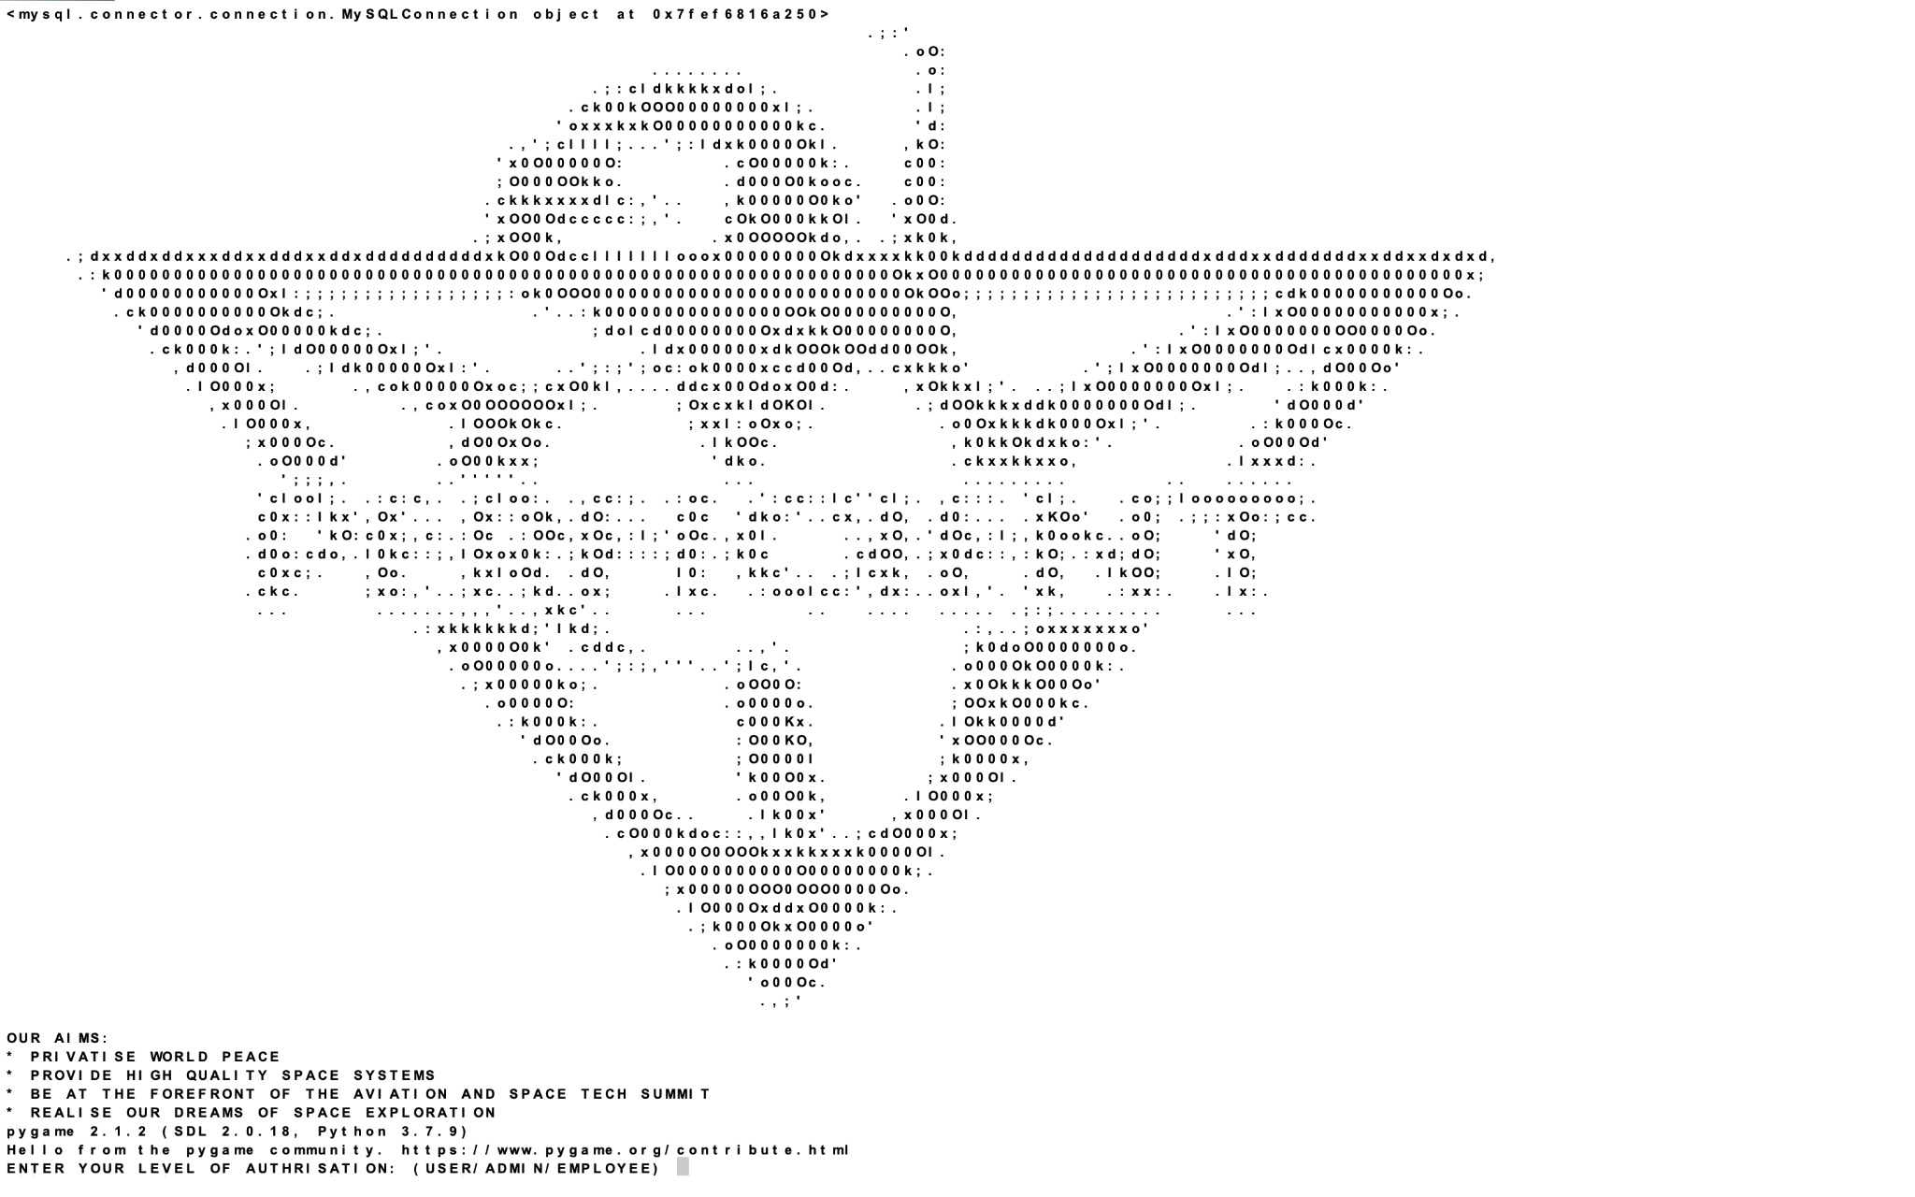

***USER***

***BUSINESS USER***

**USER CREATION**

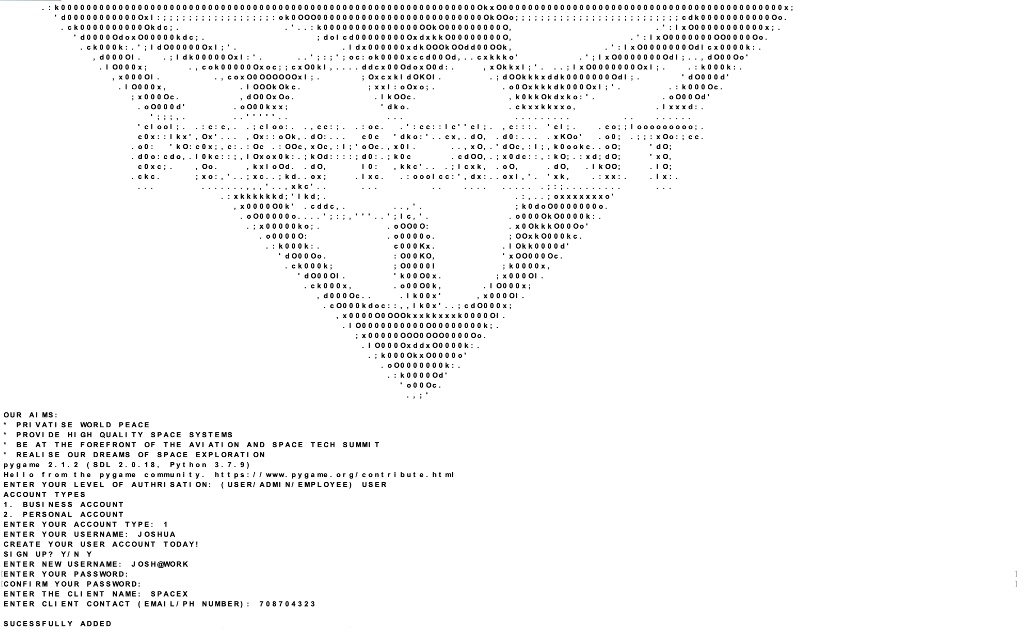

**INCORRECT PASSWORD WITH INCORRECT SECURITY CODE**

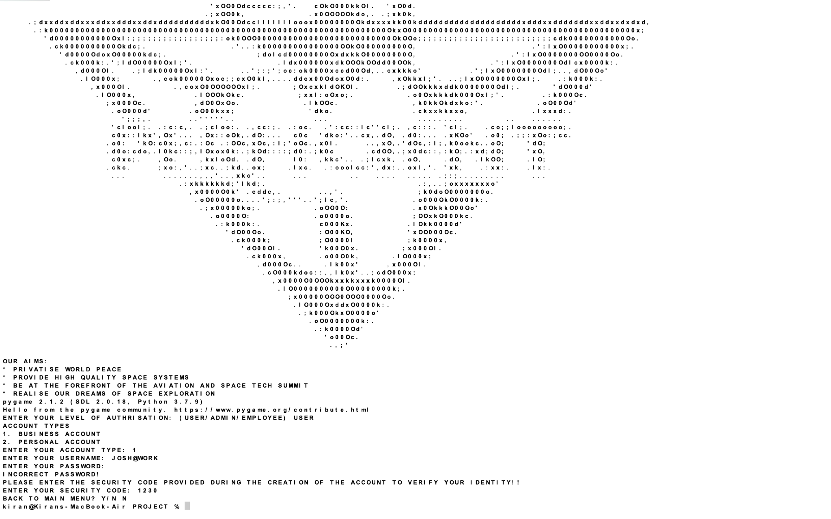

**INCORRECT PASSWORD WITH CORRECT SECURITY CODE**

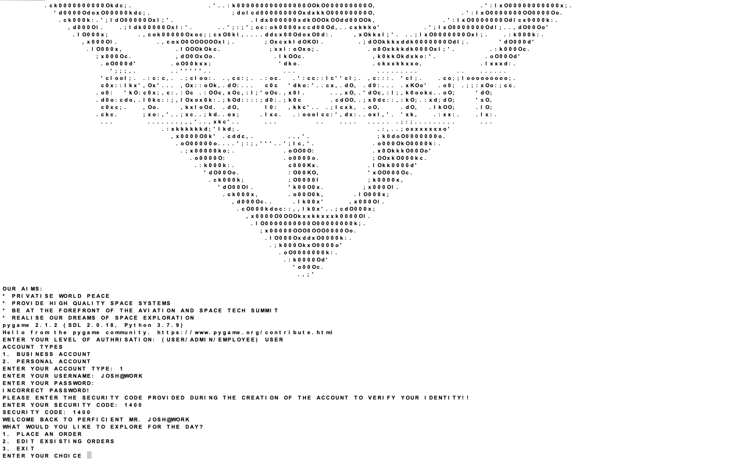

**PLACING AN ORDER**

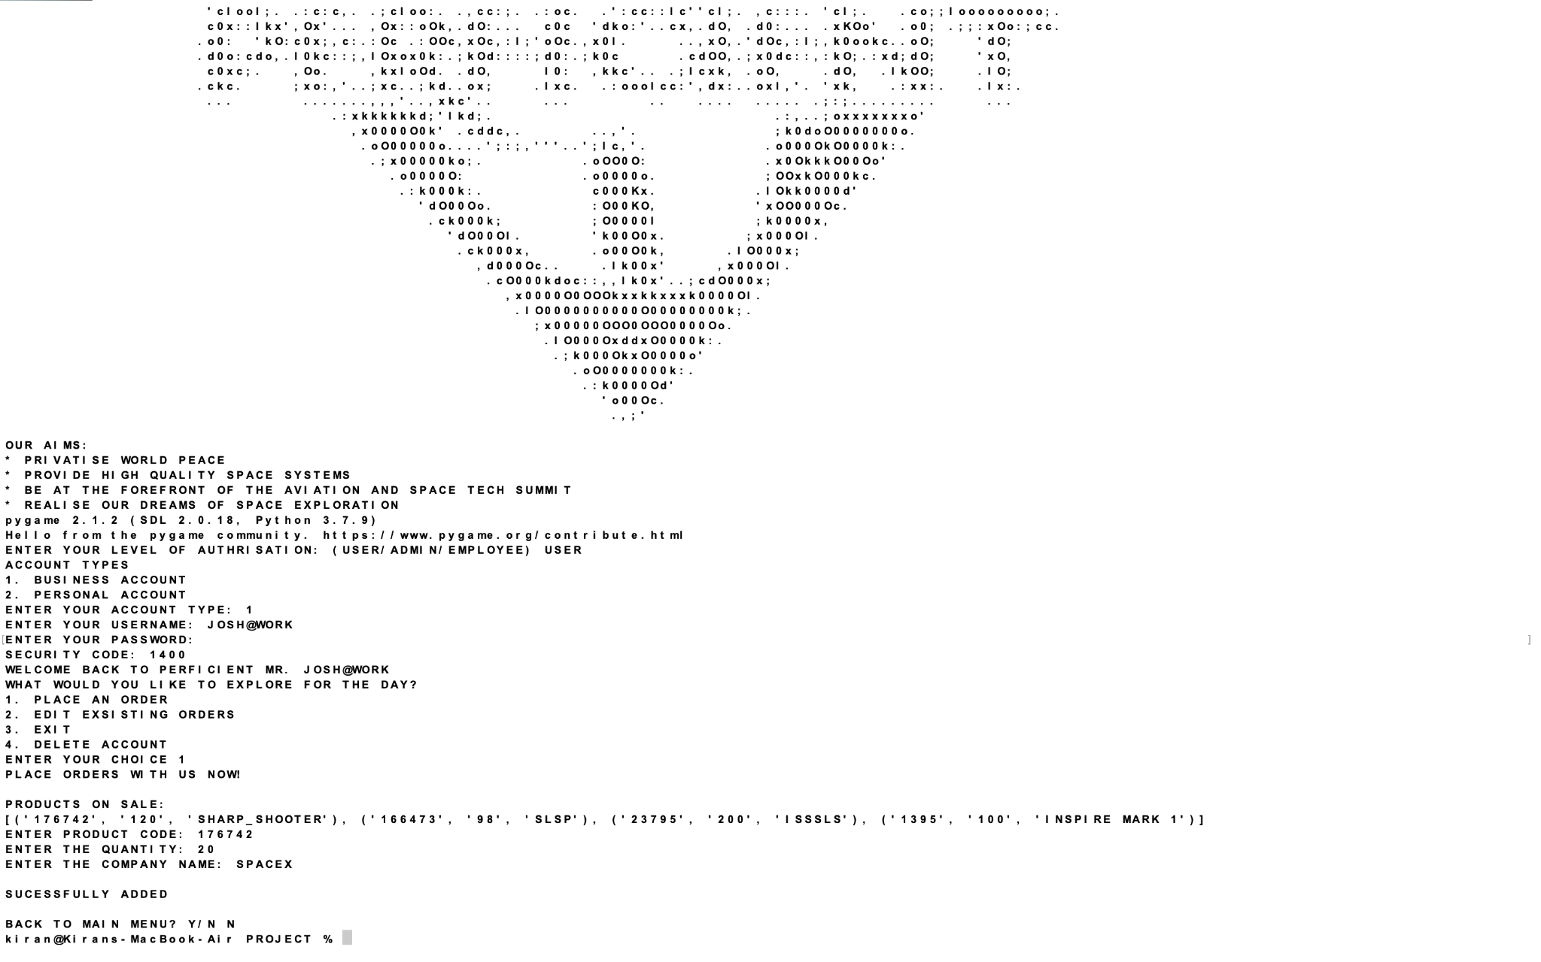

**DELETE ORDER**

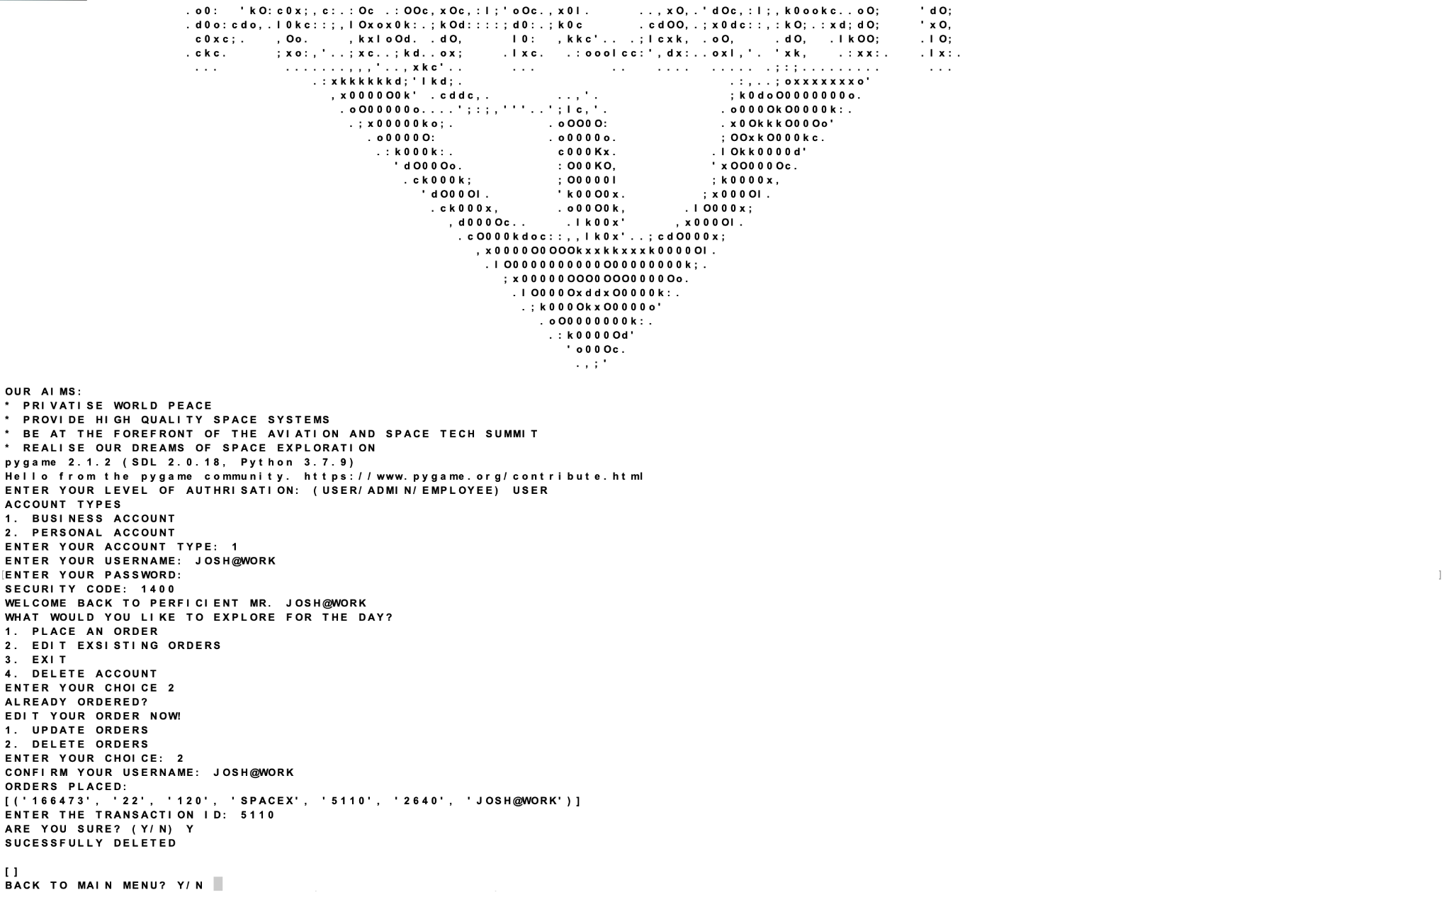

**UPDATE ORDERS (PRODUCT/QUANTITY)**

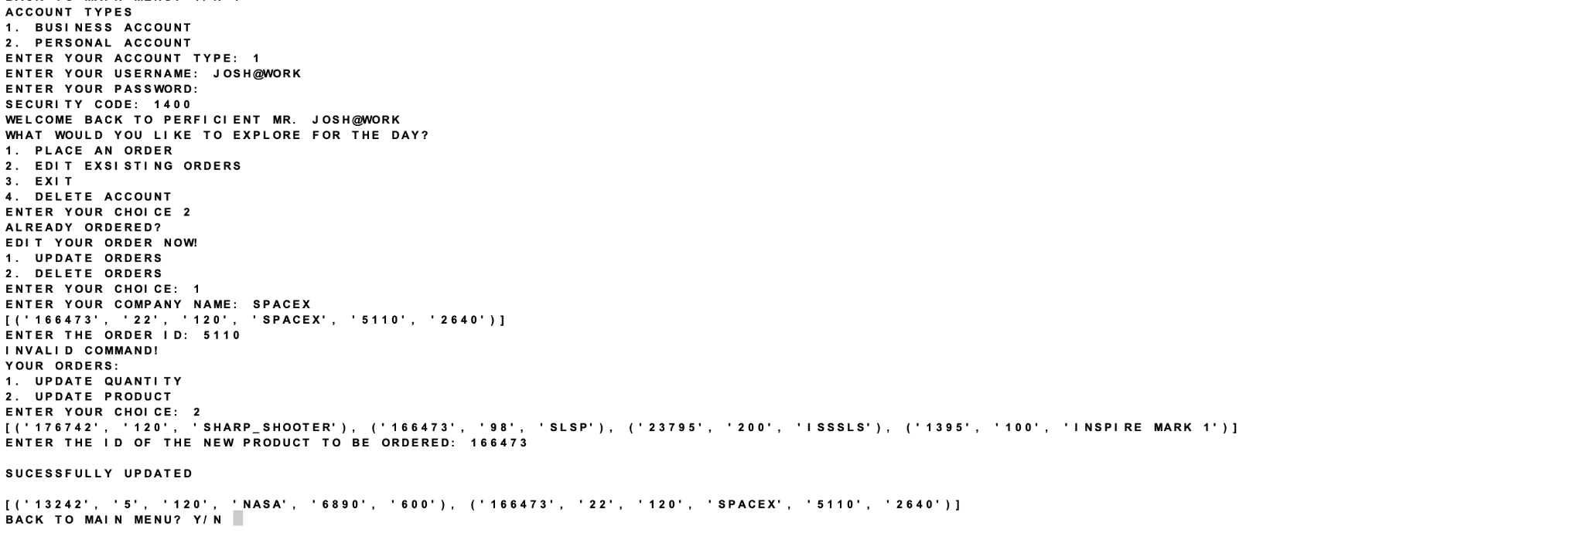

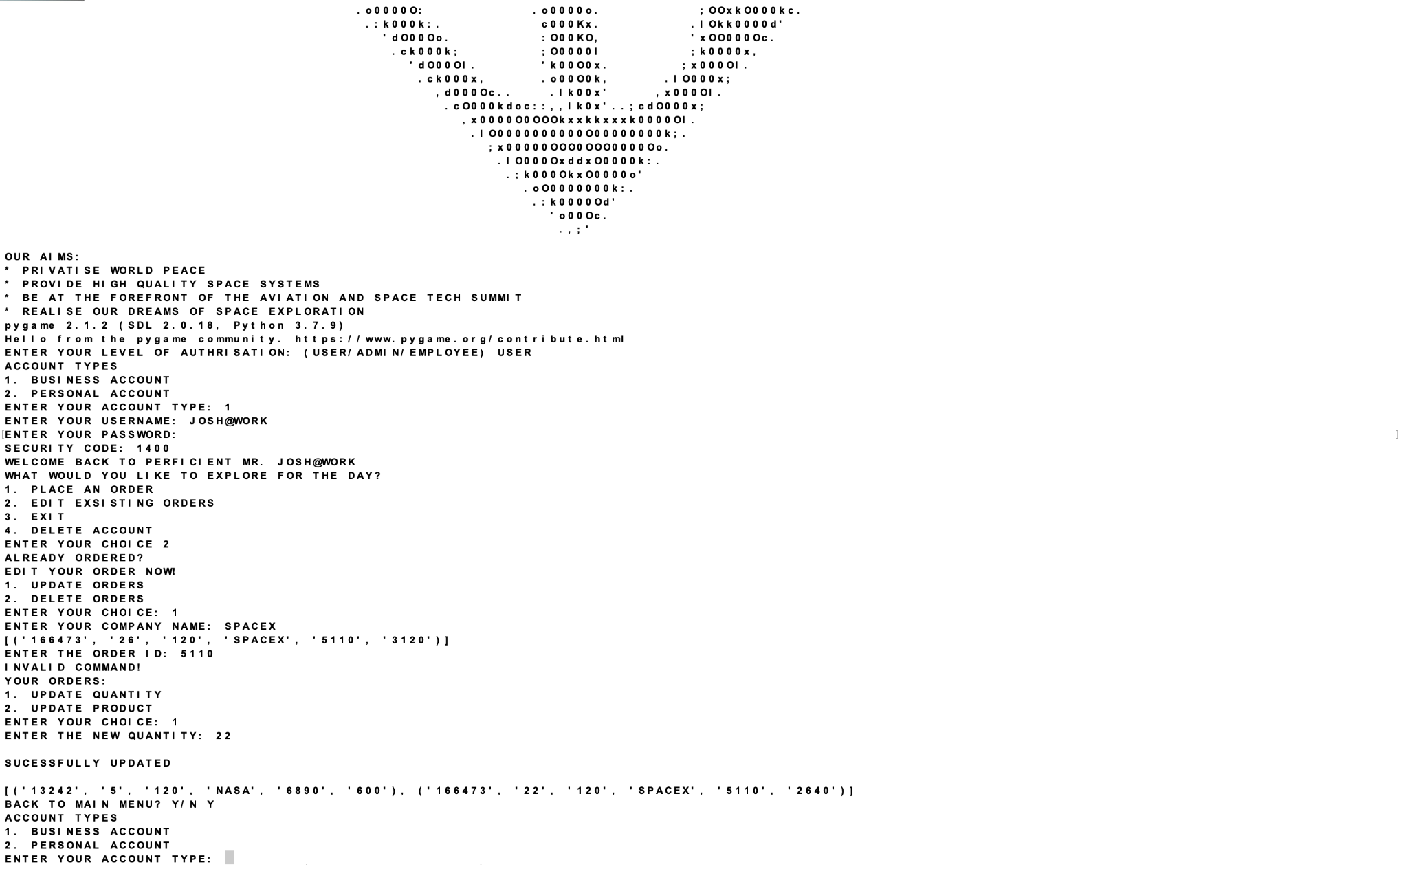

***PERSONAL USER***

**USER CREATION**

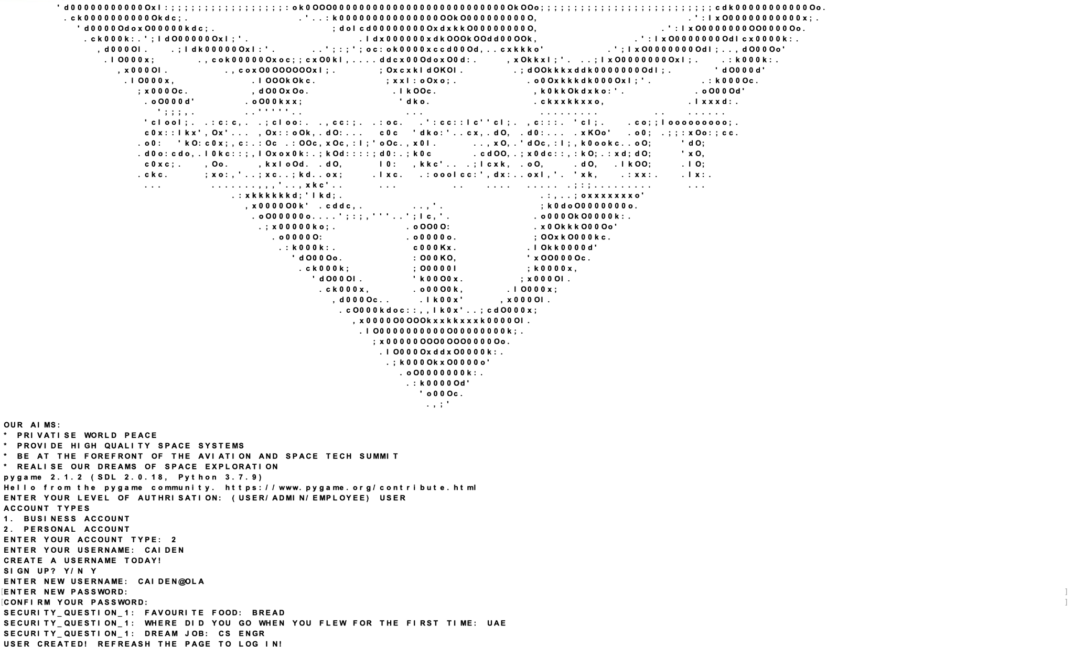

**VIEW CAREERS**

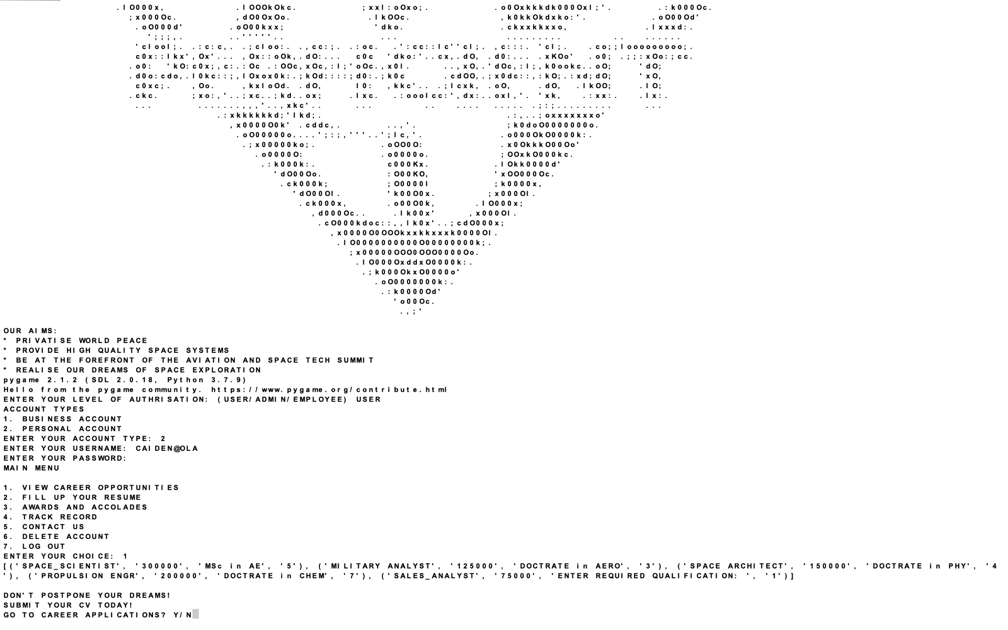

**FILL UP AN APPLICATION**

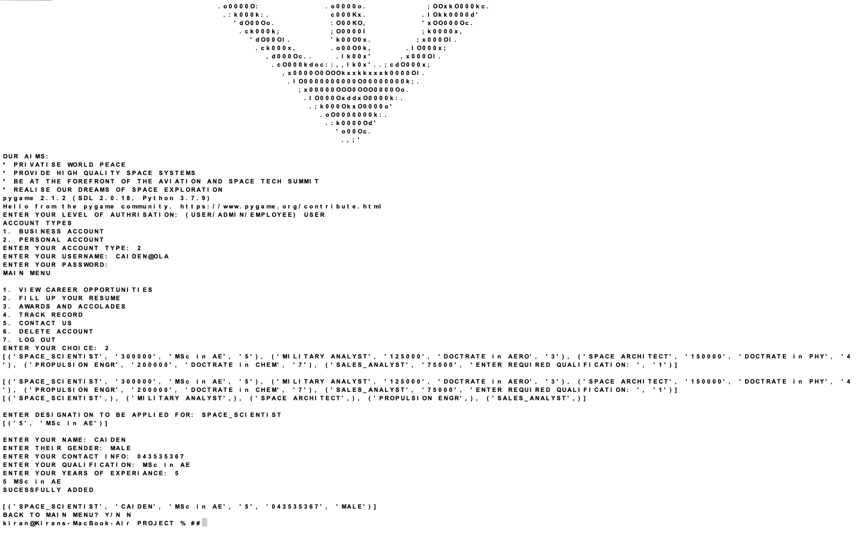

**AWARD AND ACCOLADES**

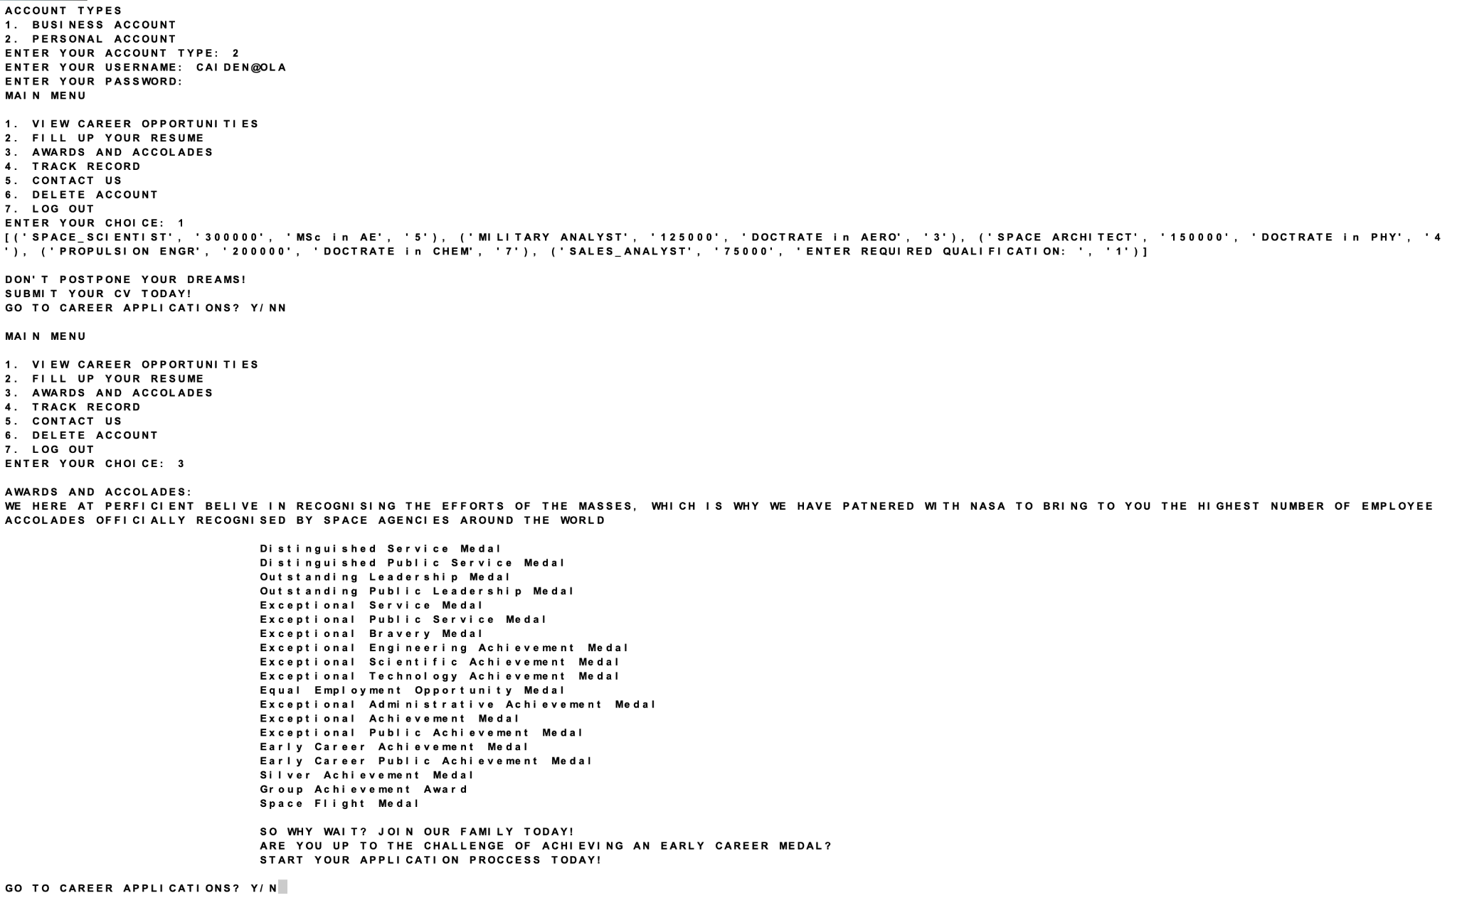

**TRACK RECORD**

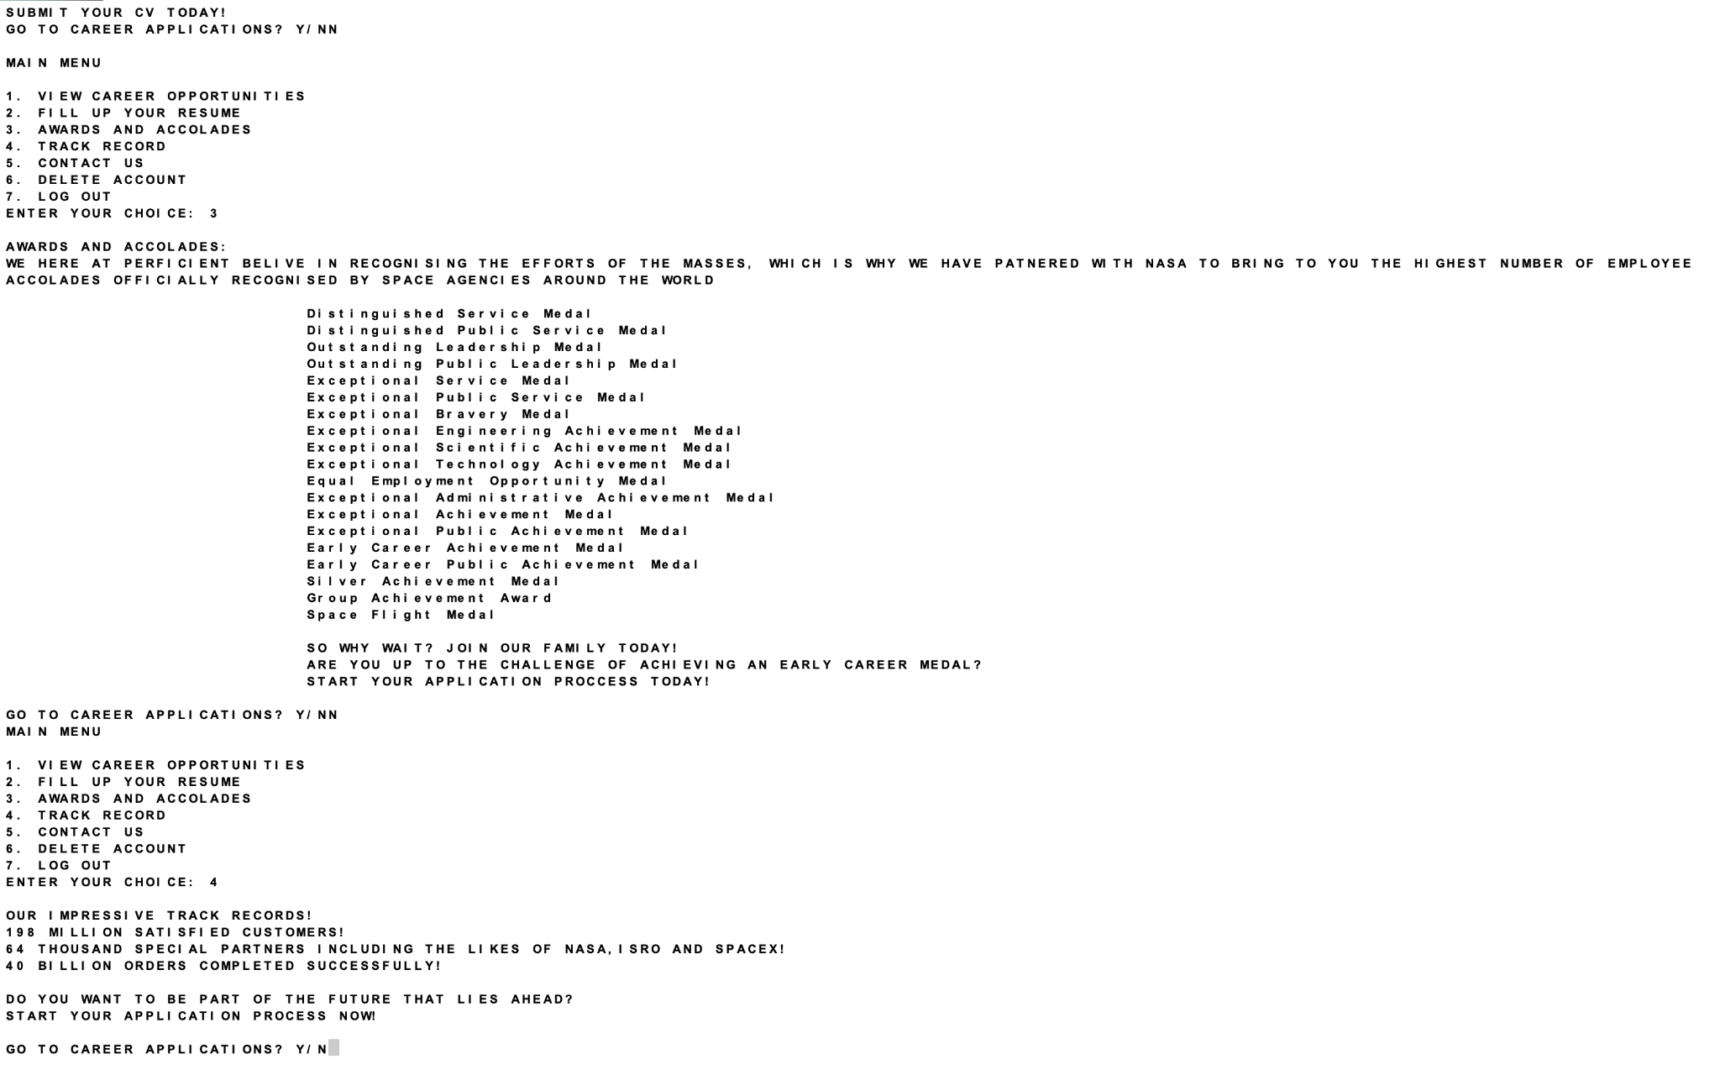

**CONTACT INFO**

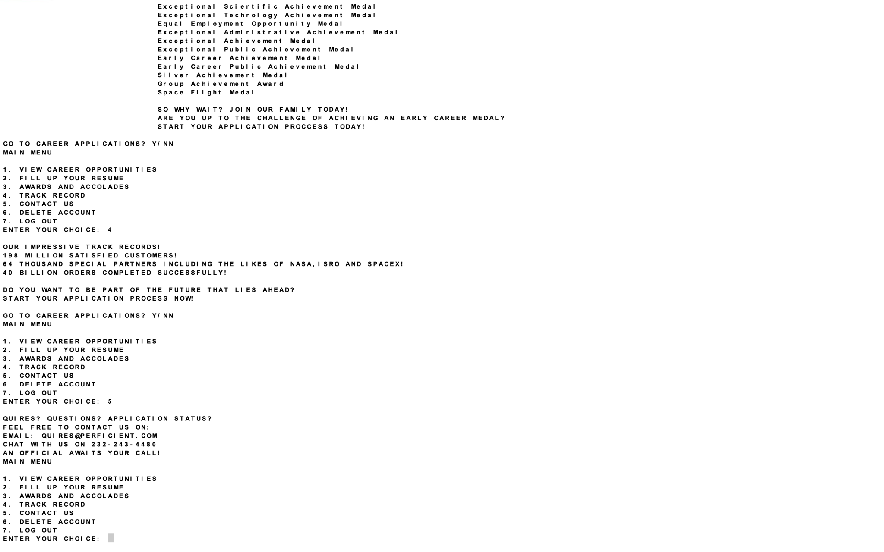

***EMPLOYEE***

**PROJECT DESIGNER**

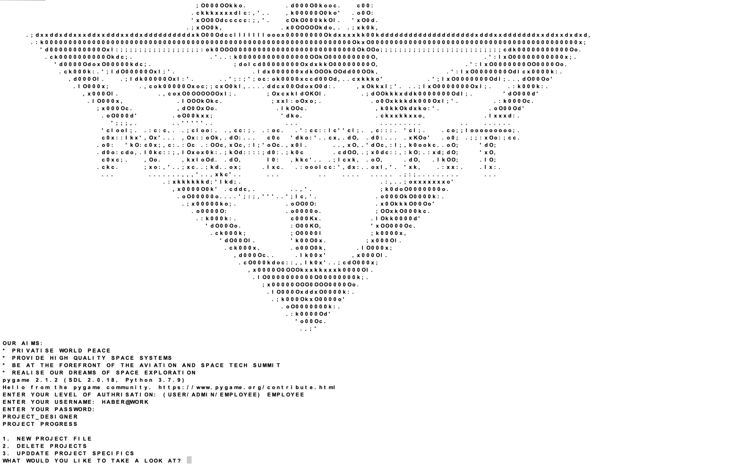

***NOTE: REFER PROJECTS MENU UNDER SUPER ADMIN FOR ITS FUNCTIONALITIES***

**PRODUCT MANAGER**

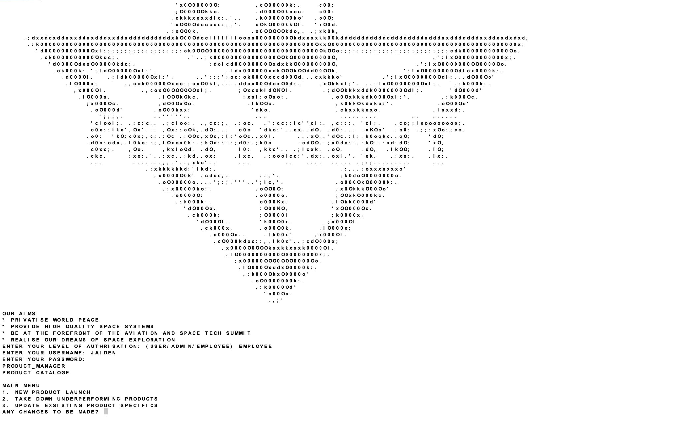

***NOTE: REFER PRODUCT MENU UNDER SUPER ADMIN FOR ITS FUNCTIONALITIES***

**SALES MANAGER**

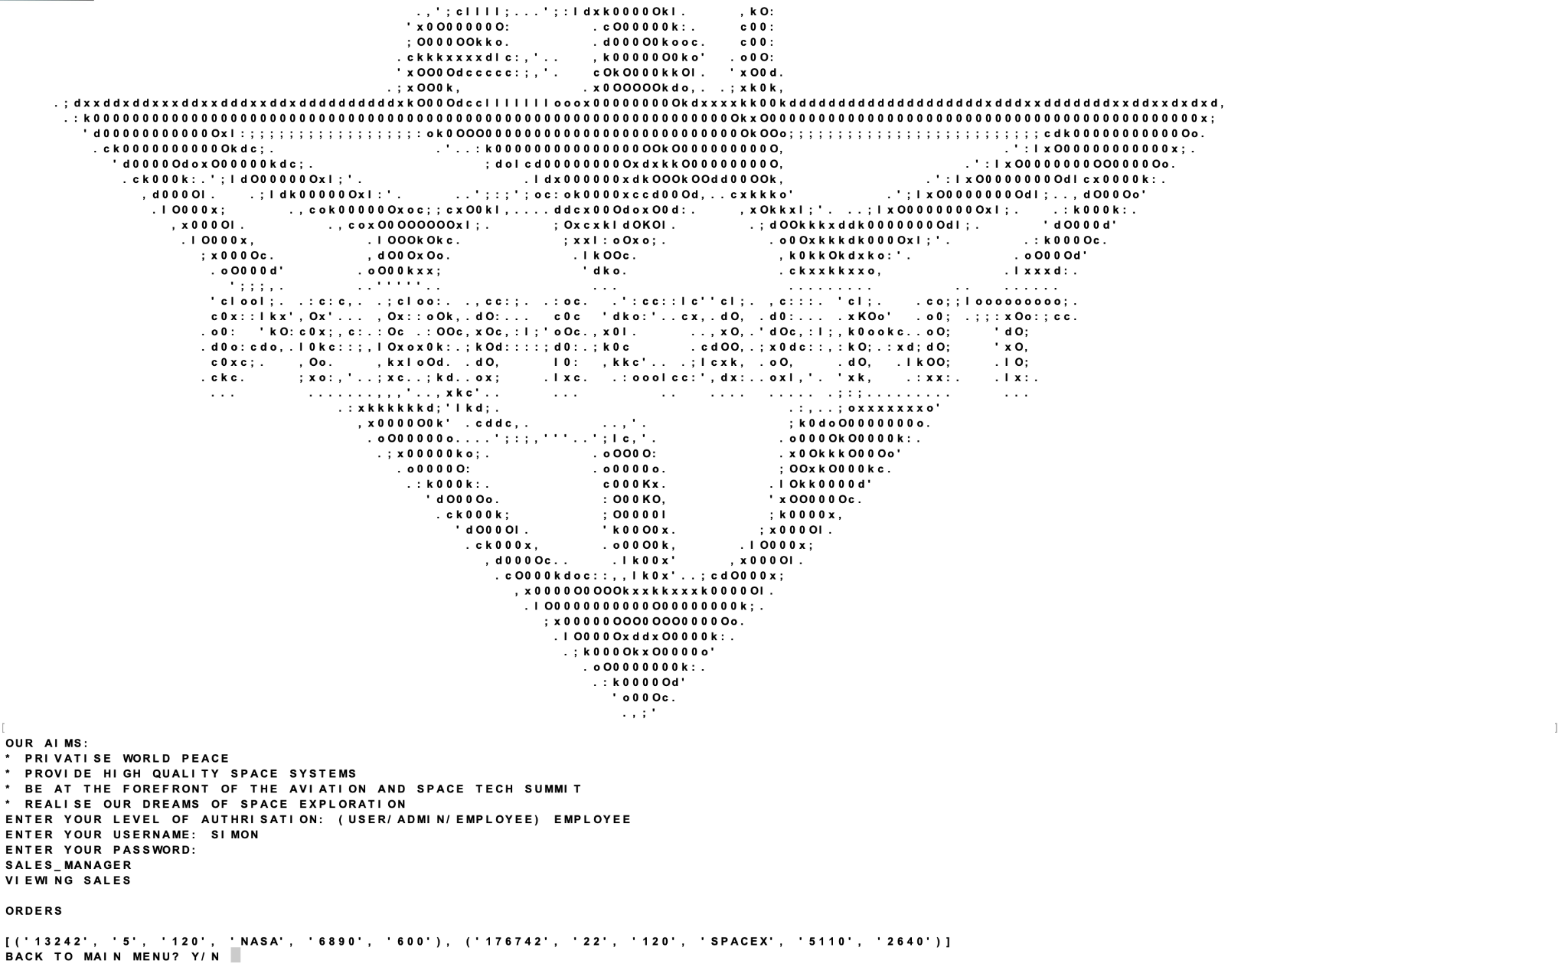

***NOTE: REFER SALES MENU UNDER SUPER ADMIN FOR ITS FUNCTIONALITIES***

***SUPER ADMIN***

**PROJECT**

**NEW**

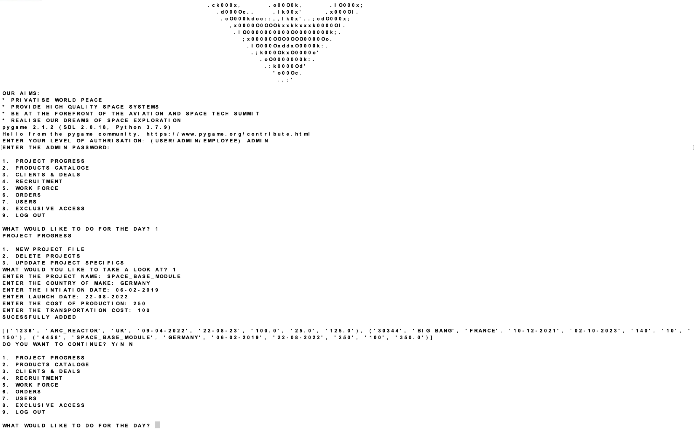

**DELETE**

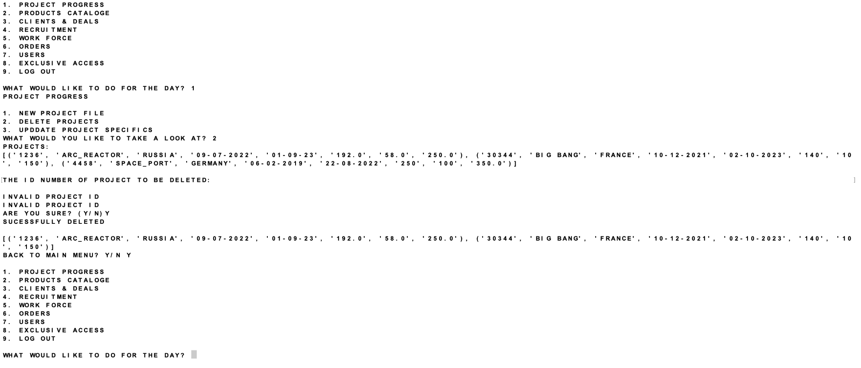

***UPDATES***

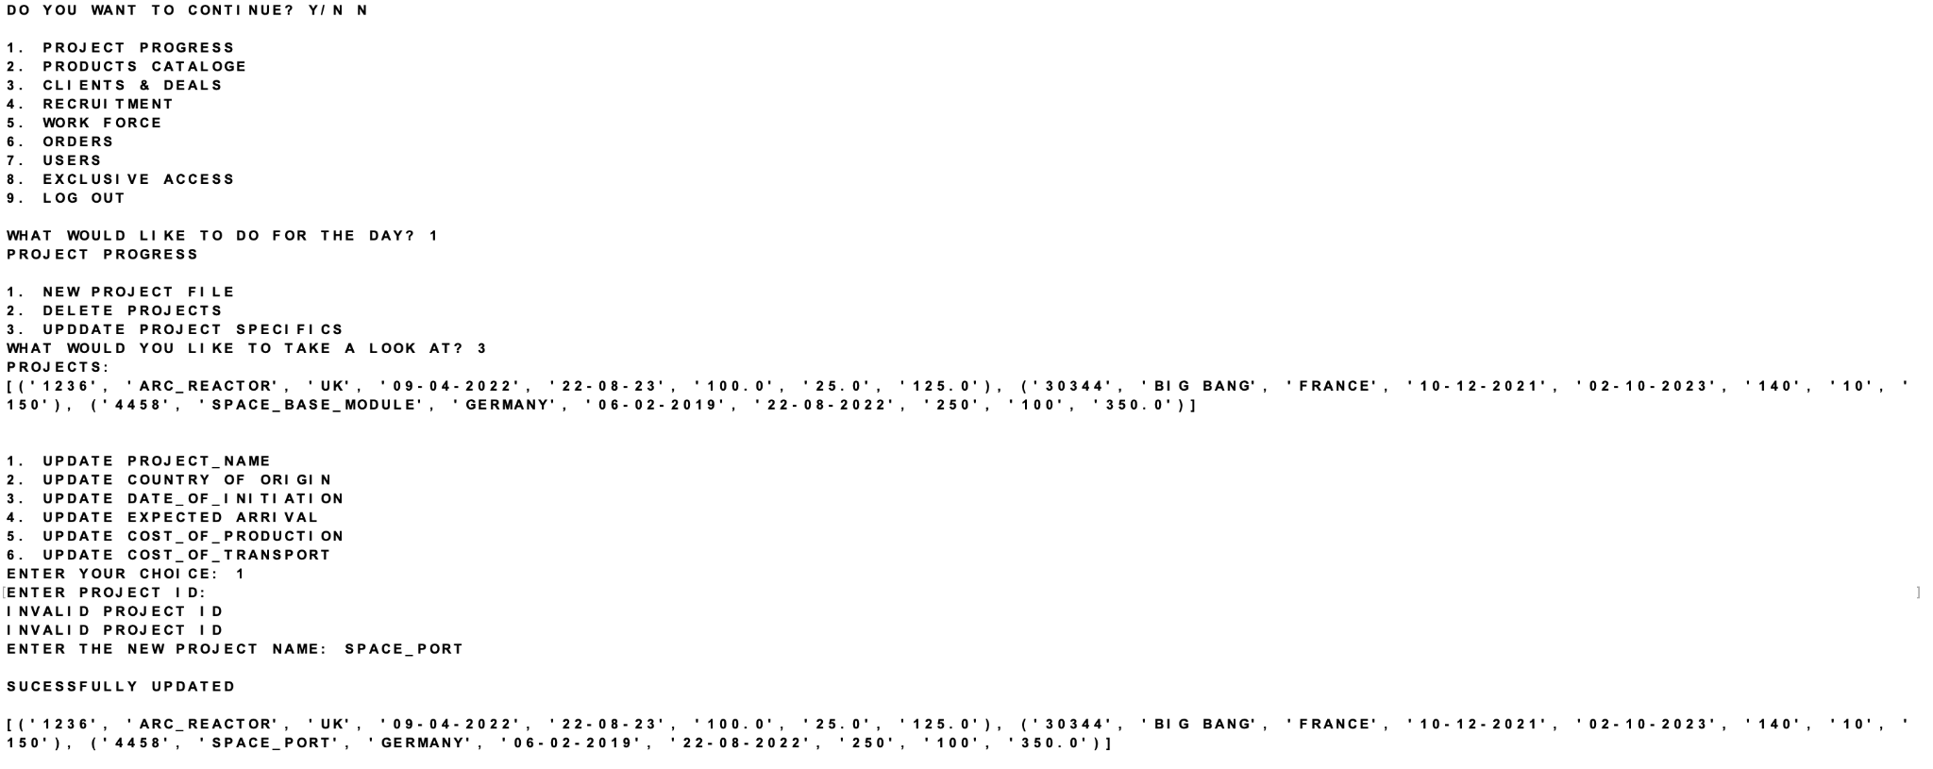

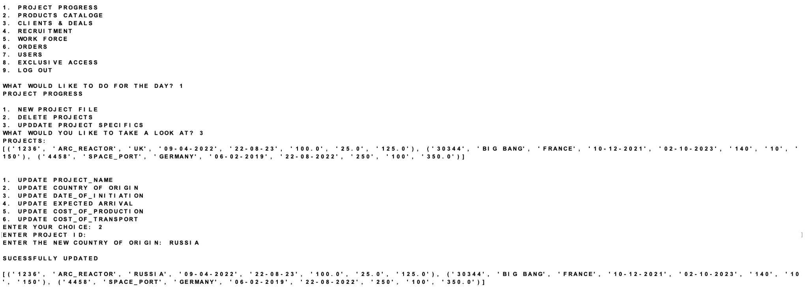

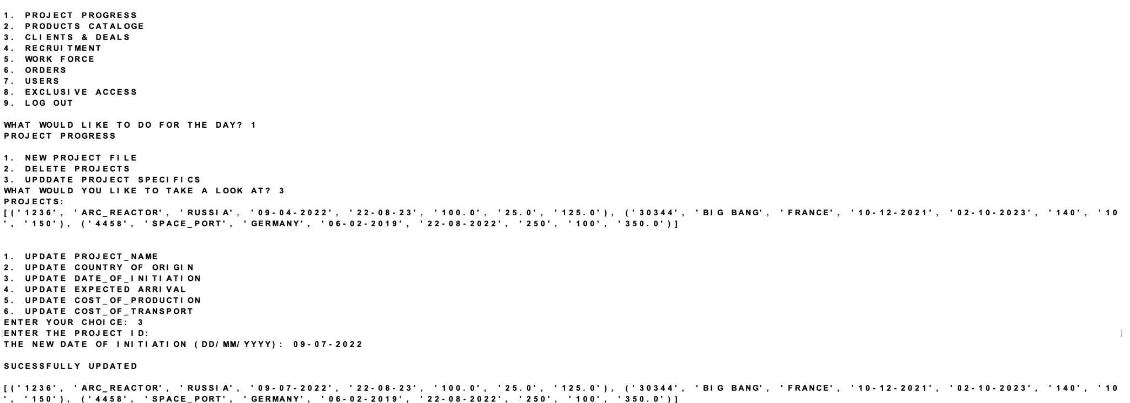

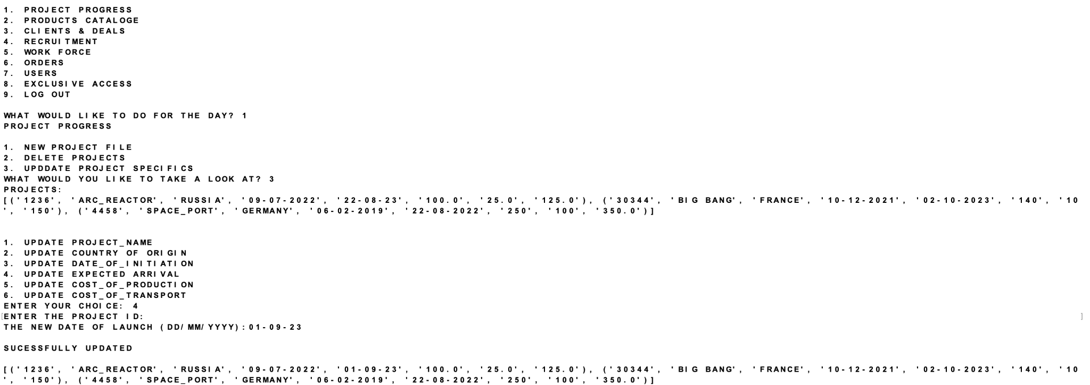

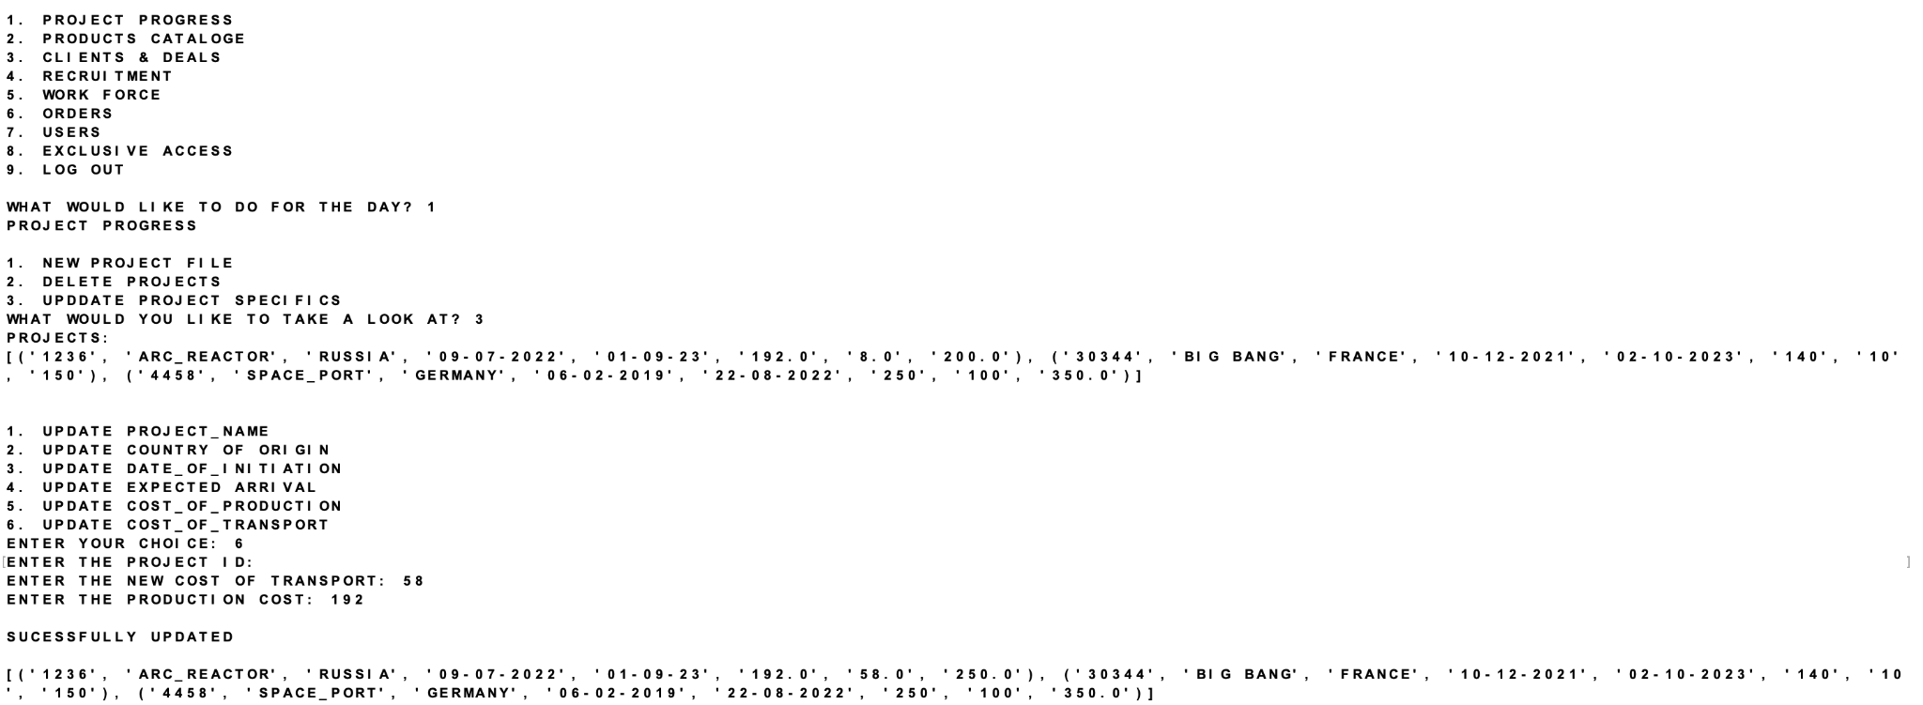

***PRODUCT***

***NEW***

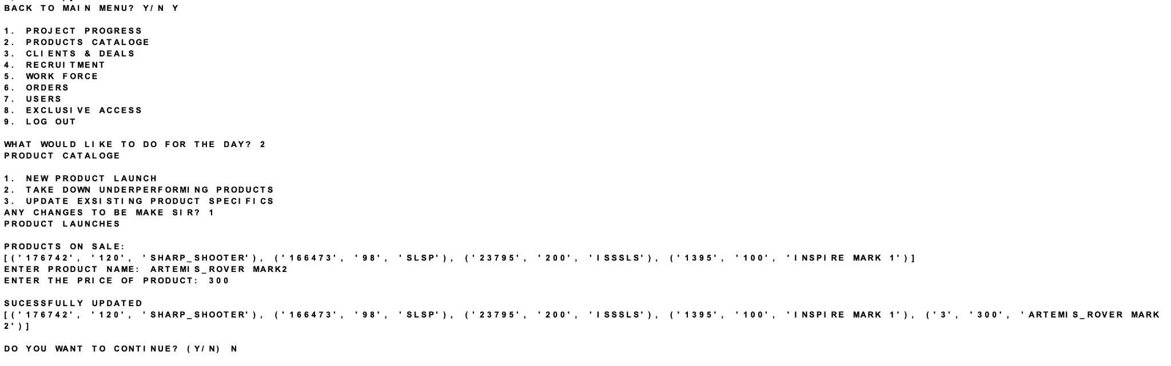

***UPDATE***

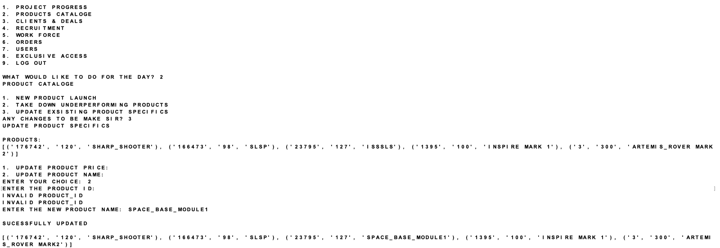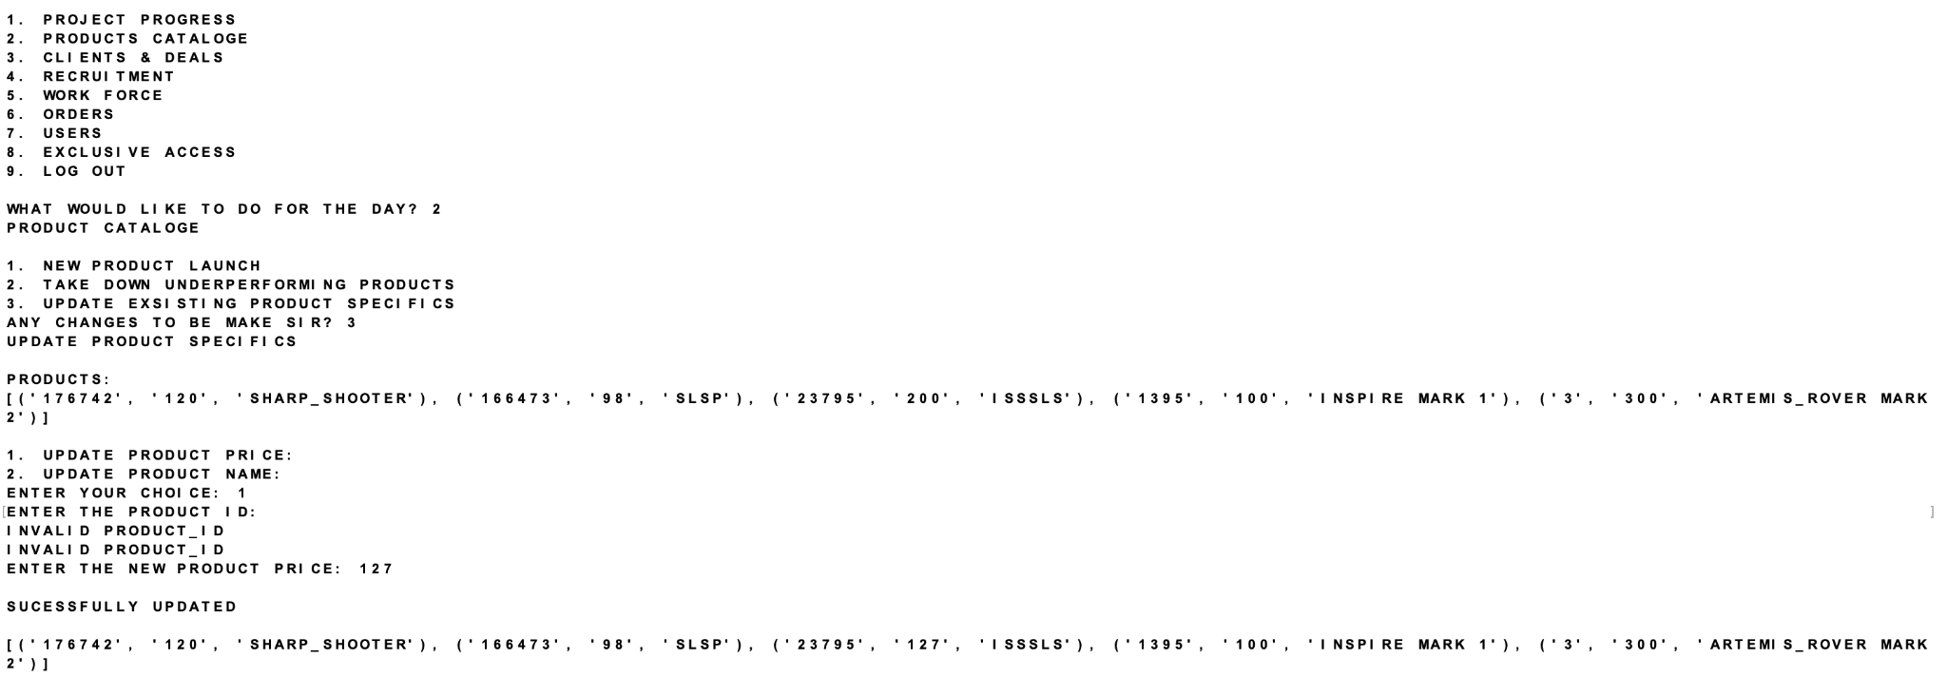

***CLIENTS***

***UPDATE***

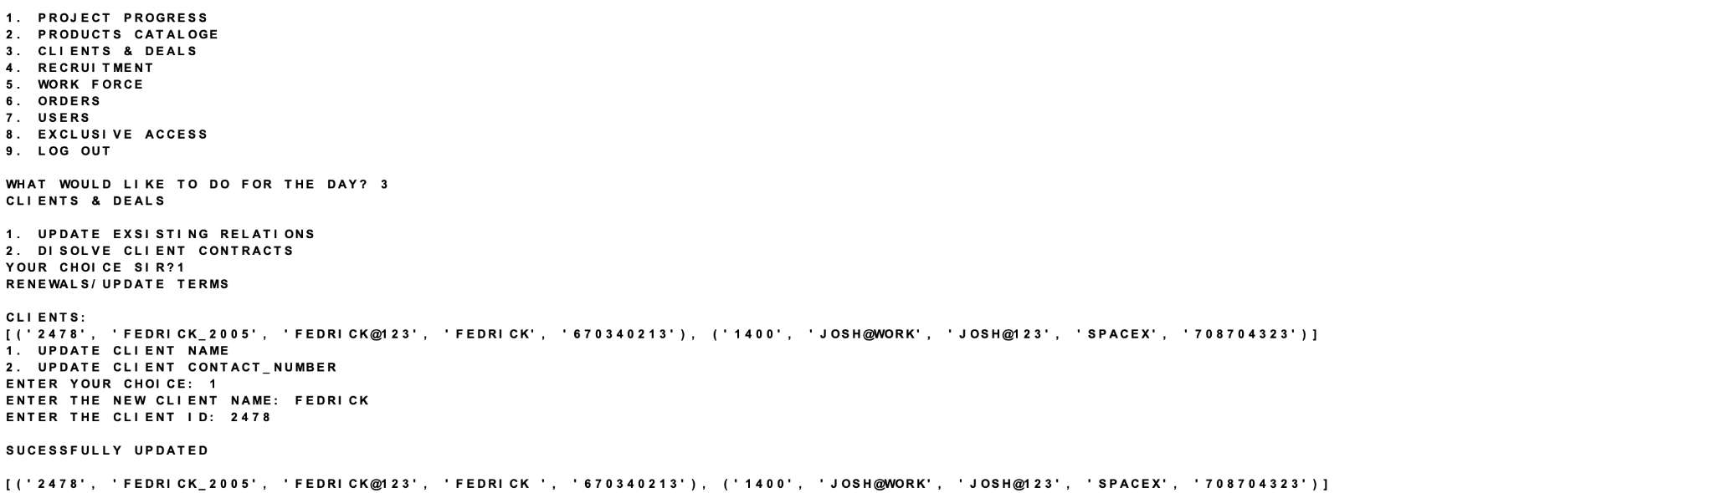

***RECRUITMENT***

***CAREER POSTINGS***

***NEW***

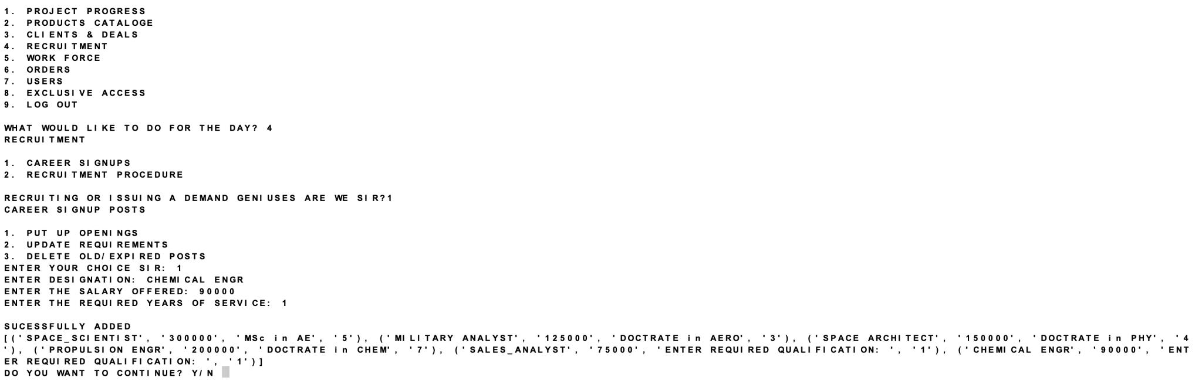

***UPDATE***

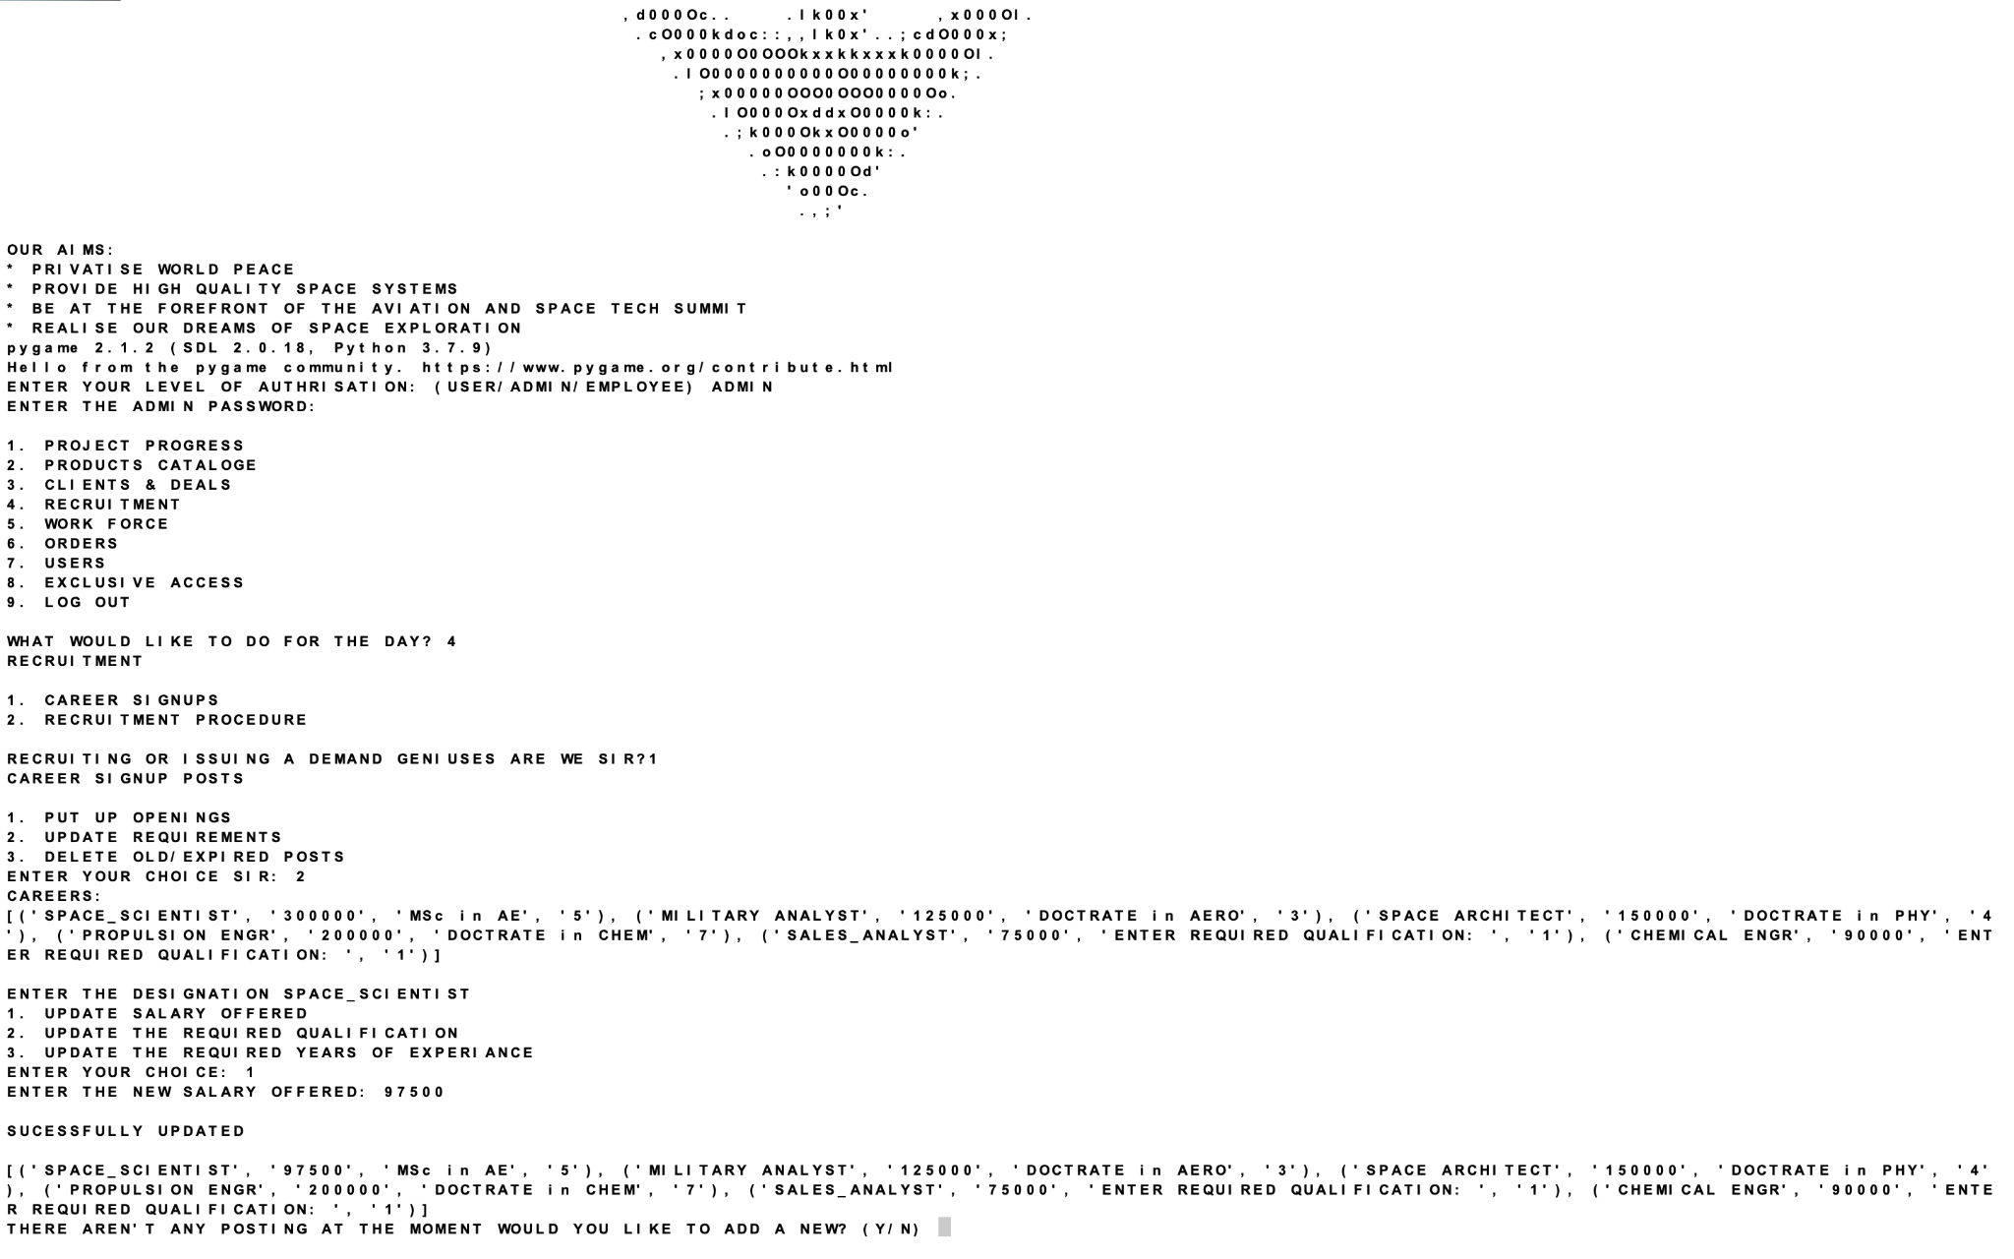

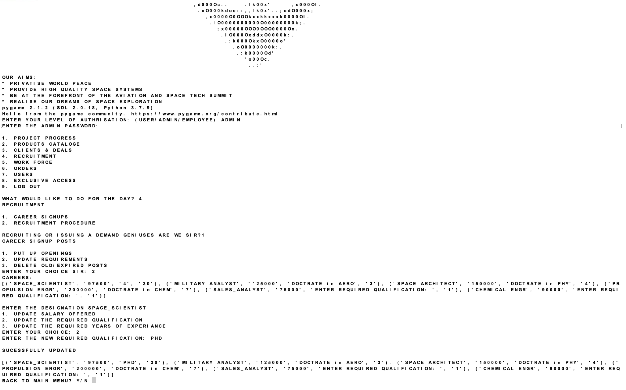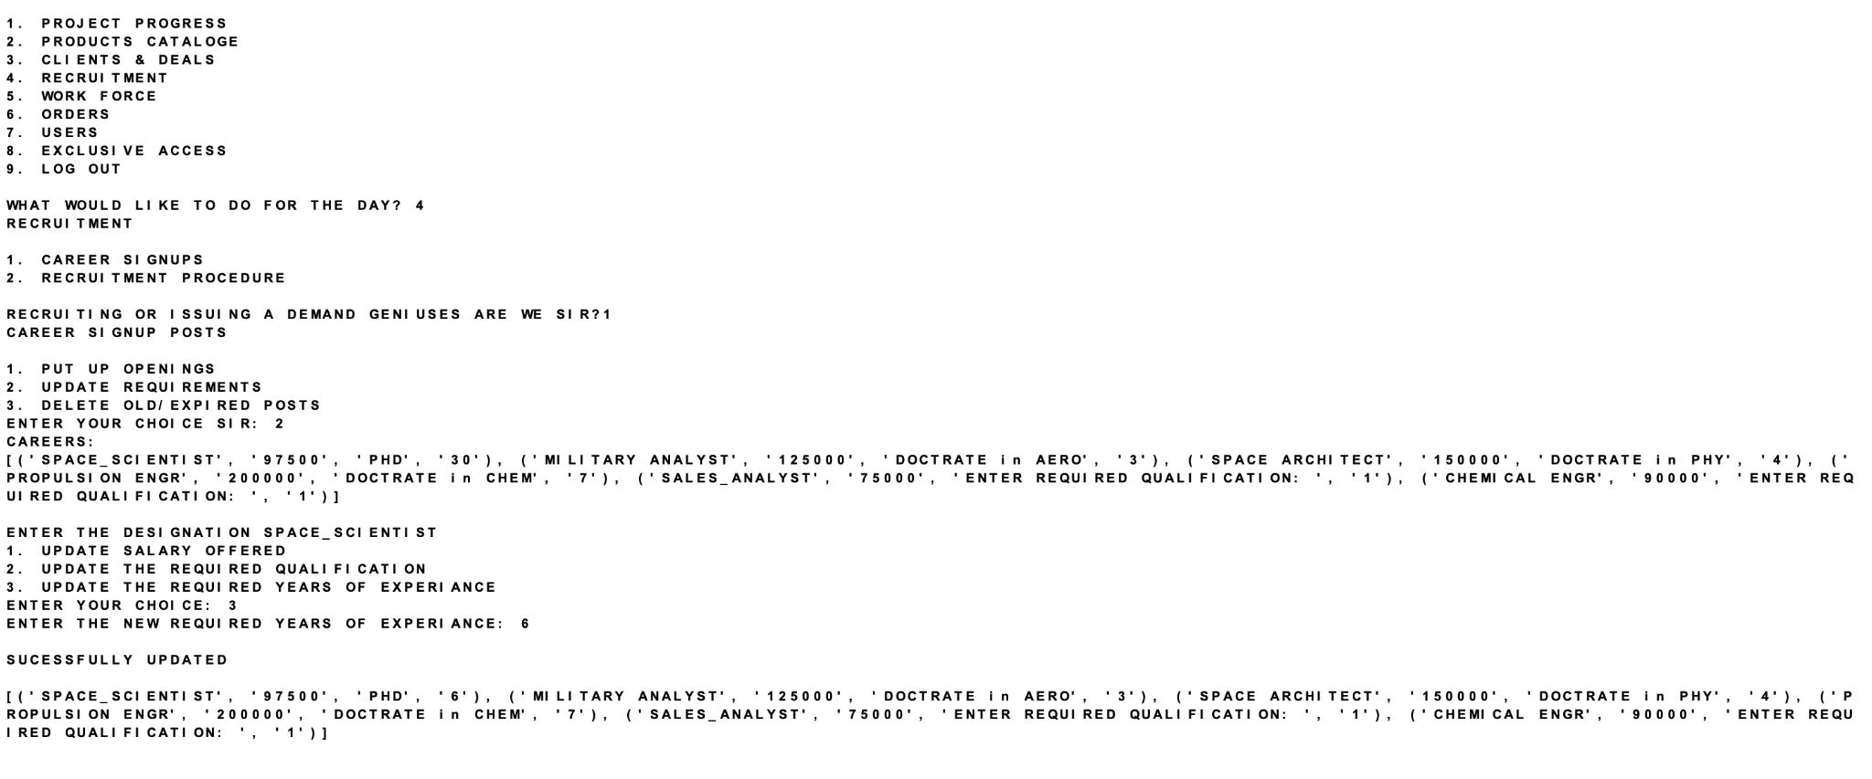

***DELETE***

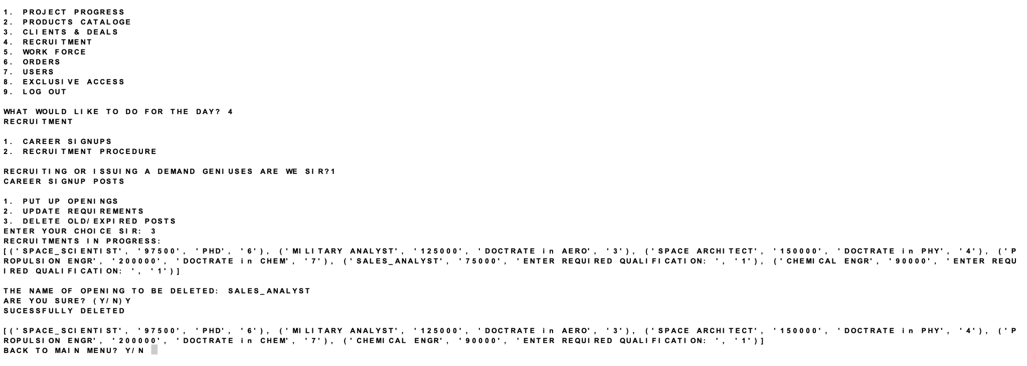

***NEW EMPLOYEES***

***WORK FORCE***

***UPDATES***

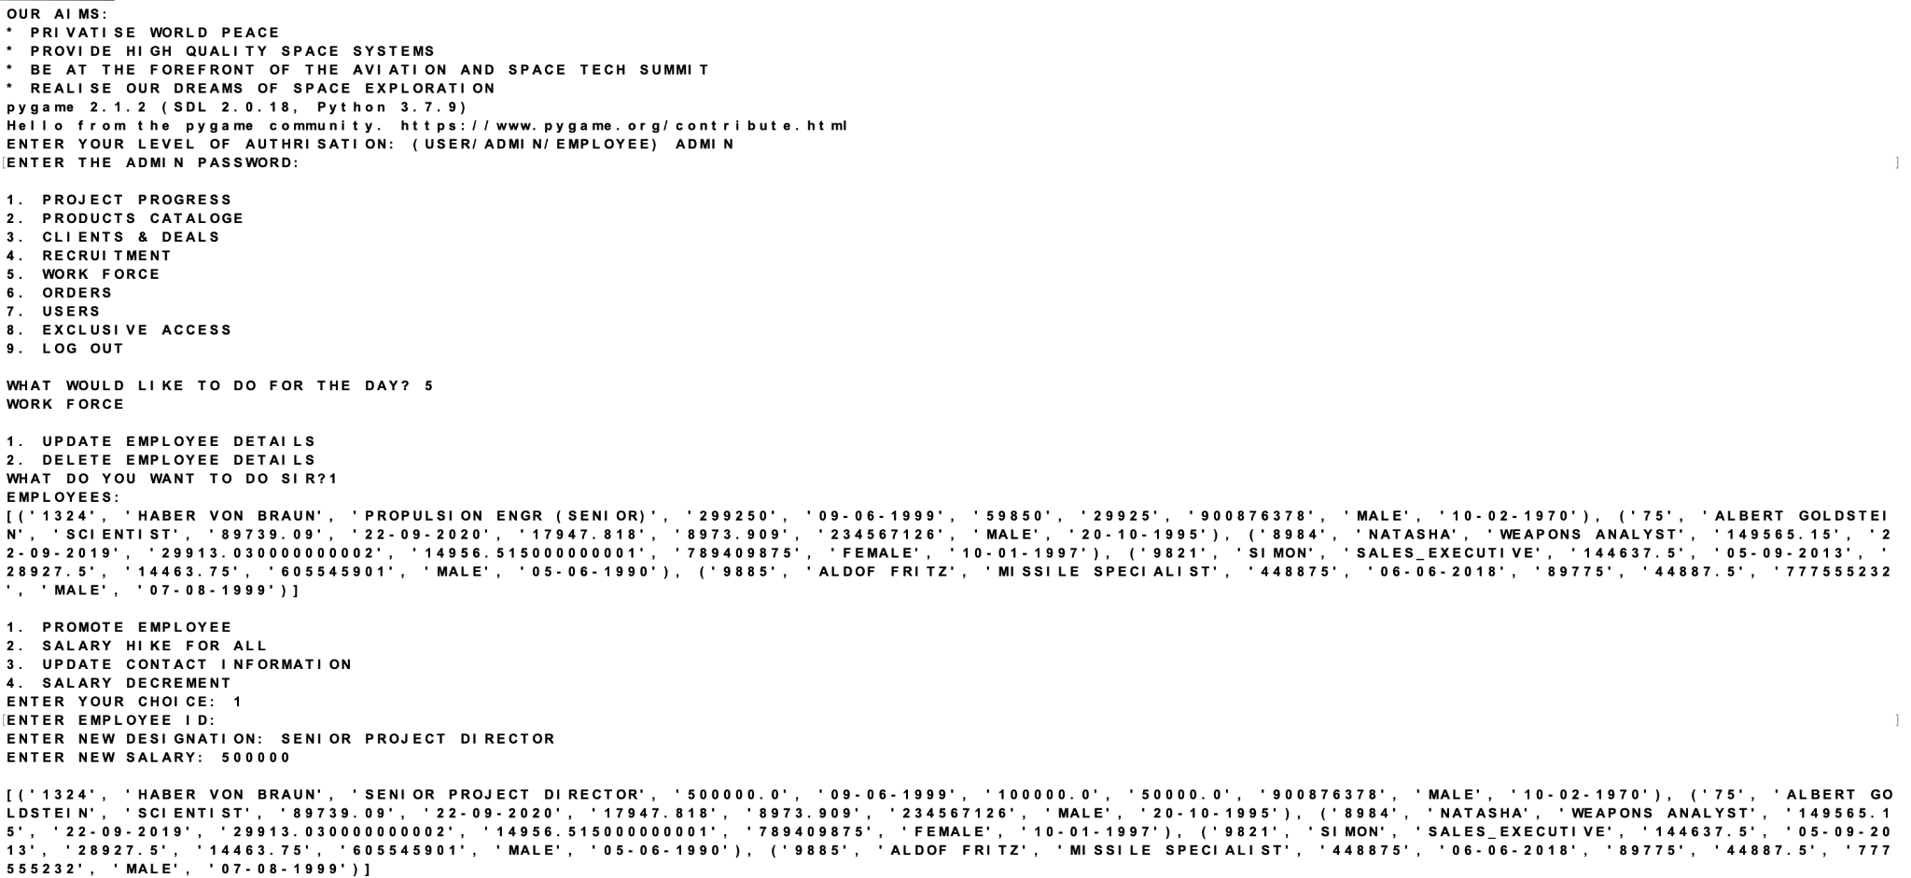

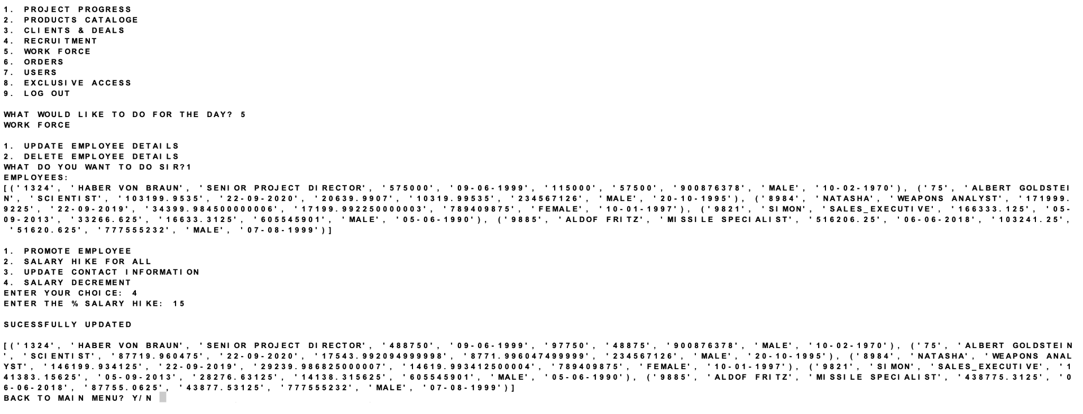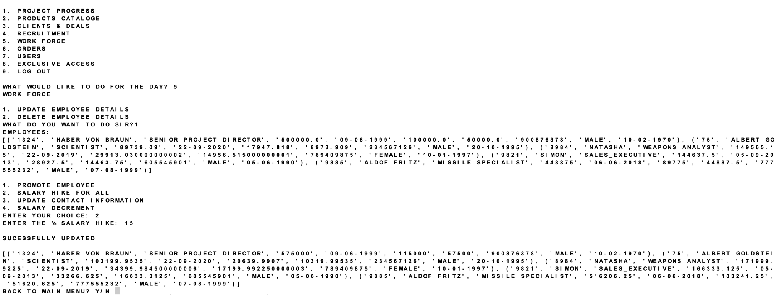



***DELETE***

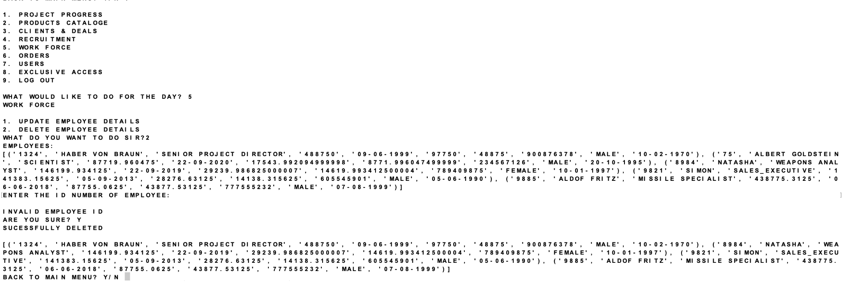

***ORDERS***

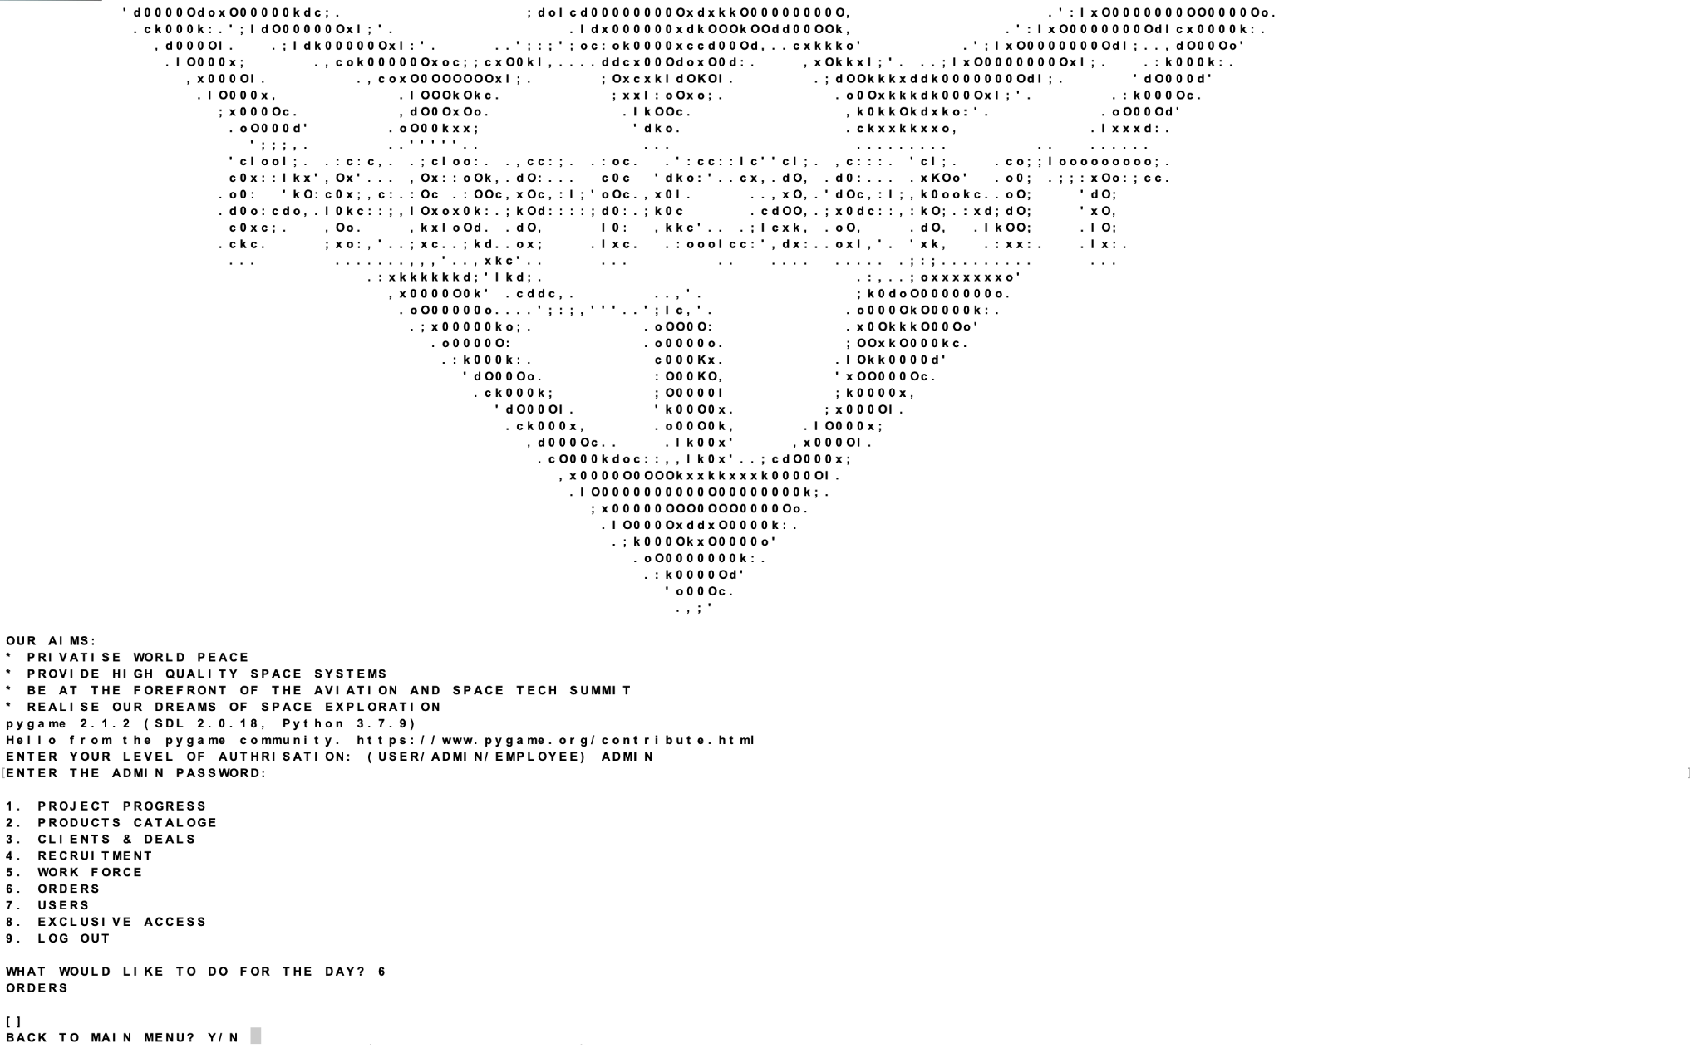

***USER***

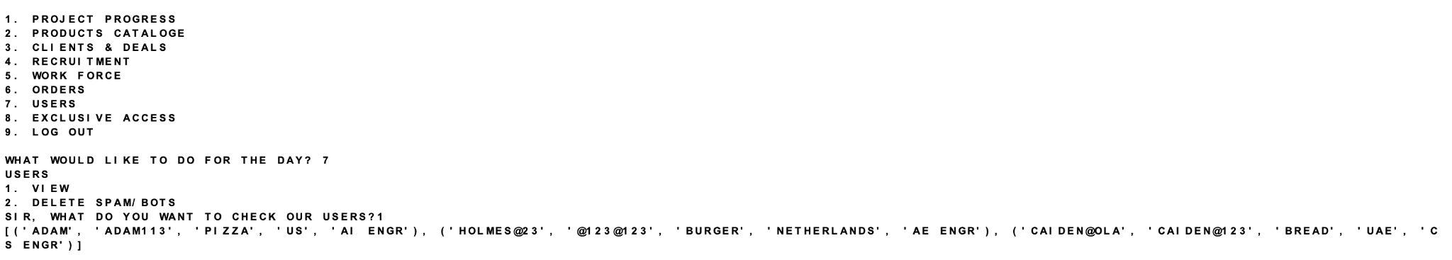

***EXCLUSIVE ACCESS***

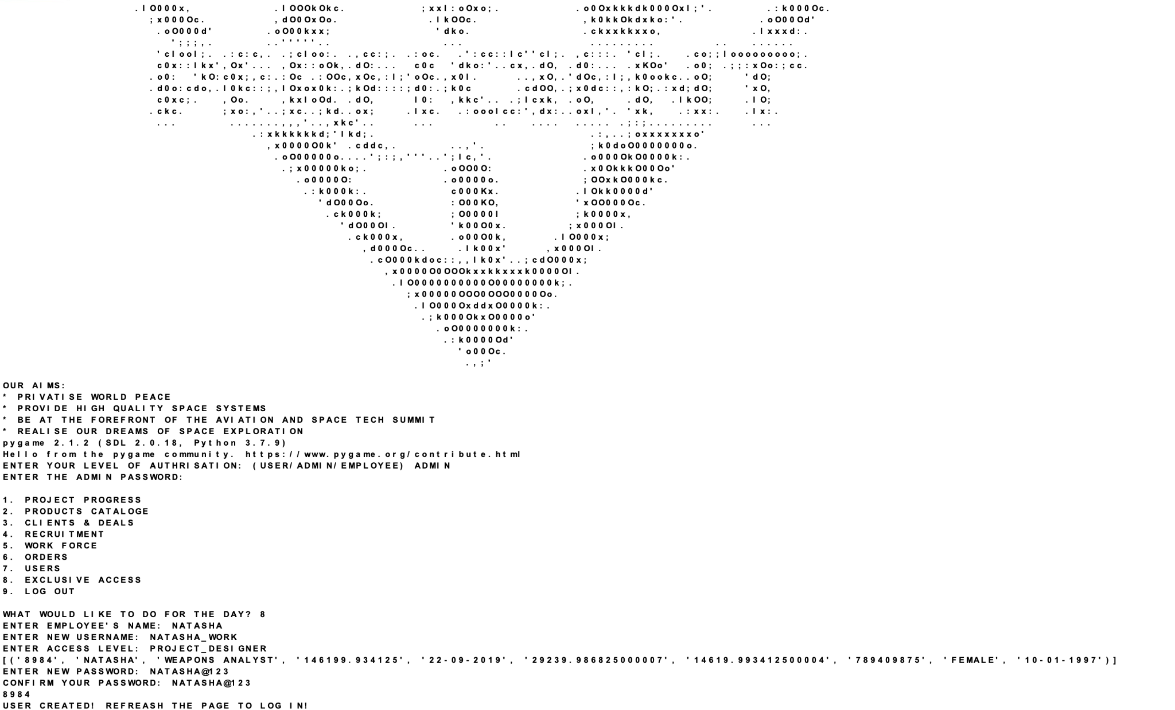

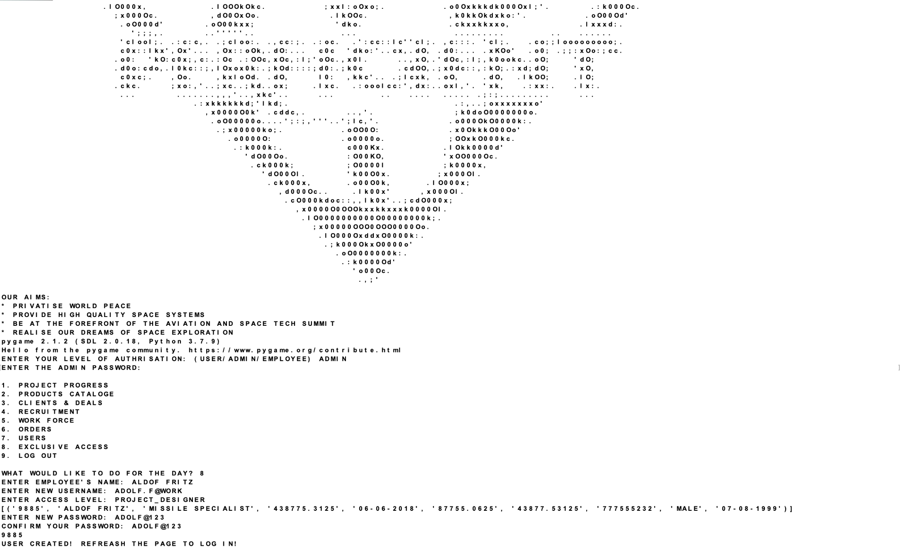

***Conclusion:***

This project has been an absolute delight! But all good things come to an end. Here we end our journey with “PERFICIENT” on a high as we were able to examine the fundamentals of business management using python-MySQL connectivity, creating three different codes for the admin, employee as well as the user of this outrageous idea of intergalactic warfare, inspired by the great Von Braun himself who dreamt of a military base on the moon!

So for the last time!

***PERFICIENT: PROFICIENT, PERFECT, AND EFFICIENT!***

***-KIRAN***

***Bibliography***

SITE REFERRED:

www.geekforgeeks.com

Books used :

1. Computer Science with Python class XII by Preeti Arora

2. Computer Science with Python class XI by Preeti Arora